**ASSIGNMENT 2 FRONT SHEET**

|  |  |  |  |
| --- | --- | --- | --- |
| **Qualification** | **BTEC Level 5 HND Diploma in Computing** | | |
| **Unit number and title** | 10: Website Design & Development | | |
| **Submission date** | 26/12/2022 | **Date Received 1st submission** |  |
| **Re-submission Date** |  | **Date Received 2nd submission** |  |
| **Student Name** | Le Tai Nhan | **Student ID** | GCD210460 |
| **Class** | GCD1102 | **Assessor name** | Phyo Min Tun |
| **Student declaration**  I certify that the assignment submission is entirely my own work and I fully understand the consequences of plagiarism. I understand that making a false declaration is a form of malpractice. | | | |
|  |  | **Student’s signature** |  |

**Grading grid**

|  |  |  |  |  |  |  |
| --- | --- | --- | --- | --- | --- | --- |
| P5 | P6 | P7 | M4 | M5 | D2 | D3 |
|  |  |  |  |  |  |  |

|  |  |  |
| --- | --- | --- |
| **❒ Summative Feedback: ❒ Resubmission Feedback:** | | |
| **Grade:** | **Assessor Signature:** | **Date:** |
| **Signature & Date:** | | |

Table of Contents

I. CREATE A DESIGN DOCUMENT FOR A BRANDED, MULTIPAGE WEBSITE SUPPORTED WITH MEDIUM FIDELITY WIREFRAMES AND A FULL SET OF CLIENT AND USER REQUIREMENTS (P5) 8

1. User’s Requirements 8

1.1. Customer 8

1.2. Manager 8

2. Review accessibility standards and guidelines 8

3. Use cases diagram 11

4. Wireframes 14

4.1. Home page 14

4.2. Login Page 16

4.3. Sign Up Page 17

4.4. Profile 18

4.5. View Cart Page 19

4.6. Update Profile Page 20

5. Sitemap 21

II. USE YOUR DESIGN DOCUMENT WITH APPROPRIATE PRINCIPLES, STANDARDS AND GUIDELINES TO PRODUCE A BRANDED, MULTIPAGE WEBSITE SUPPORTED WITH REALISTIC CONTENT (P6) 22

1. Source code Samples of the Website 22

2. Screenshots of Final website with explanation 83

2.1. Landing page 83

2.2. Register page 84

2.3. Login page 86

2.4. Profile page and Update profile 87

2.5. Cart page 88

3. Features of the website 90

3.1. Create action 90

3.2. Read action 90

3.3. Update action 91

3.4. Delete action 91

3.5. Search product items by Name 93

III. CREATE A SUITABLE TEST PLAN IDENTIFYING KEY PERFORMANCE AREA AND USE IT TO REVIEW THE FUNCTIONLITY AND PERFORMANCE OF YOUR WEBSITE. USER EXPERIENCE (UX) AND USER INTERFACE (UI) (P7) 94

1. Test plan 94

References 99

Table of Figures

Figure 1: The World Wide Web Consortium (W3C) 9

Figure 2: Use case diagram 12

Figure 3: Wireframe of Homepage 14

Figure 4: Wireframe of Login page 16

Figure 5: Sign Up page 17

Figure 6: Wireframe of Profile page 18

Figure 7: View Cart Page 19

Figure 8: Update Profile Page 20

Figure 9: Website diagram 21

Figure 10: aboutus.php 23

Figure 11: addcart.php (1) 24

Figure 12: addcart.php (2) 24

Figure 13: categories.php 25

Figure 14: complete.php 26

Figure 15: contact.php (1) 27

Figure 16: contact.php (2) 28

Figure 17: contact.php (3) 29

Figure 18: finish.php 30

Figure 19: footer.php 31

Figure 20: index.php (1) 32

Figure 21: index.php (2) 33

Figure 22: index.php (3) 34

Figure 23: invoice.php (1) 35

Figure 24: invoice.php (2) 36

Figure 25: invoice.php (3) 37

Figure 26: invoice.php (4) 38

Figure 27: invoice.php (5) 39

Figure 28: invoice.php (6) 40

Figure 29: invoice.php (7) 40

Figure 30: login.php (1) 41

Figure 31: login.php (2) 42

Figure 32: login.php (3) 42

Figure 33: logout.php 43

Figure 34: mainmenu.php 43

Figure 35: menupanel.php 44

Figure 36: myaccount.php 44

Figure 37: orderdelete.php 45

Figure 38: orderhistory.php (1) 46

Figure 39: orderhistory.php (2) 47

Figure 40: orderhistory.php (3) 48

Figure 41: ordertable.php (1) 49

Figure 42: ordertable.php (2) 50

Figure 43: ordertable.php (3) 51

Figure 44: ordertable.php (4) 52

Figure 45: ordertable.php (5) 52

Figure 46: orderupdate.php 53

Figure 47: payment.php (1) 54

Figure 48: payment.php (2) 55

Figure 49: payment.php (3) 56

Figure 50: payment.php (4) 57

Figure 51: paymentsave.php 58

Figure 52: policies.php (1) 59

Figure 53: policies (2) 59

Figure 54: productdetail.php (1) 60

Figure 55: productdetail.php (2) 61

Figure 56: productlist.php (1) 62

Figure 57: productlist.php (2) 63

Figure 58: productlist.php (3) 64

Figure 59: productlist.php (4) 65

Figure 60: productlist.php (5) 66

Figure 61: productlish.php (6) 66

Figure 62: registration.php (1) 67

Figure 63: registration.php (2) 68

Figure 64: registration.php (3) 69

Figure 65: search.php 70

Figure 66: shipment.php (1) 71

Figure 67: shipmentphp (2) 72

Figure 68: shipment.php (3) 73

Figure 69: shipmentsave.php 73

Figure 70: special.php (1) 74

Figure 71: special.php (2) 75

Figure 72: topbanner.php (1) 76

Figure 73: topbanner.php (2) 77

Figure 74: userdetail.php (1) 78

Figure 75: userdetail.php (2) 79

Figure 76: userdetail.php (3) 80

Figure 77: useredit.php (1) 81

Figure 78: useredit.php (2) 82

Figure 79: validateuser.php 83

Figure 80: Home page 84

Figure 81: Register page 85

Figure 82: Login Page 86

Figure 83: Profile page 87

Figure 84: Update profile page 88

Figure 85: Cart page 89

Figure 86: Create action 90

Figure 87: Displayed information 90

Figure 88: Update action 91

Figure 89: Delete action 92

Figure 90: Example of search product 93

Figure 91 95

Figure 92 96

Figure 93 96

Figure 94 97

Figure 95 98

# CREATE A DESIGN DOCUMENT FOR A BRANDED, MULTIPAGE WEBSITE SUPPORTED WITH MEDIUM FIDELITY WIREFRAMES AND A FULL SET OF CLIENT AND USER REQUIREMENTS (P5)

## User’s Requirements

### Customer

* As a consumer, I would want to set up a user account with secure information so that I may log in and make purchases on the website.
* I would like to put the products I want to my shopping basket in order to make purchases.
* I want to update my personal information as a customer so that I can correct and make it more accurate as well as change it when my information is leaked
* I want to see the shop's information and policies

### Manager

* I want to modify, add, or remove some items needed for the shop as a manager.
* As a manager, I need to see the user's username, address, phone number, and email address so that I can get in touch with them right away.
* To determine which products have been sold, as a manager I can view the products added to the customer's cart
* As a manager, I must know how much each cart in order to keep track of sales.

## Review accessibility standards and guidelines

International Web standards including HTML, CSS, and many more are created by the World Wide Web Consortium (W3C). Web standards created by the W3C are known as recommendations. (Henry, 2022)

The Working Group on Accessible Platform Architectures (APA) examines all W3C standards for support of accessibility.

Accessibility is especially pertinent to the W3C standards and Working Group Notes that are discussed below.



Figure 1: The World Wide Web Consortium (W3C)

* **Web Content Accessibility Guidelines (WCAG) 2:**
  + Web "content" is a broad term for the data on a web page or in a web application, such as:
    - Text, pictures, and audio are examples of natural information. Structure, presentation, etc. are defined by markup or code.
  + Dynamic content, multimedia, "mobile," and other topics are covered by WCAG. Information and communications technologies (ICT) other than web-based can also be subject to WCAG, as explained in WCAG2ICT.
  + WCAG 2 info:
    - WCAG Overview
    - WCAG 2.1 at a Glance
    - How to Meet WCAG 2 (Quick Reference)
    - WCAG 2 Translations
    - WCAG 2.0 Standard
    - WCAG 2.1 Standard, What’s New in WCAG 2.1
    - What’s New in WCAG 2.2 Draft
* **Authoring Tool Accessibility Guidelines (ATAG):**
  + Web developers, designers, writers, and other "authors" employ authoring tools, which are programs and services, to create web content. As an illustration, consider HTML editors, content management systems (CMS), and websites that permit users to upload material, including blogs and social networking sites. ATAG papers provide instructions on:
    - Make authoring tools themselves accessible to enable the creation of web content by persons with disabilities and to assist authors in producing more accessible web content.
  + ATAG info:
    - ATAG Overview
    - ATAG at a Glance
    - ATAG 2.0 Standard
* **User Agent Accessibility Guidelines (UAAG):**
  + User agents are software programs that render online content, such as browsers, browser add-ons, media players, readers, and other software.
  + UAAG info:
    - UAAG Overview
    - UAAG 2.0 Note
* **W3C Accessibility Guidelines (WCAG) 3 Working Draft:**
  + The goal of WCAG 3 is to become a W3C Standard. It is currently an early draft. Web applications, tools, publishing, and new technologies are all covered under WCAG 3.
  + WCAG 3 info:
    - WCAG 3 Introduction

### Use cases diagram

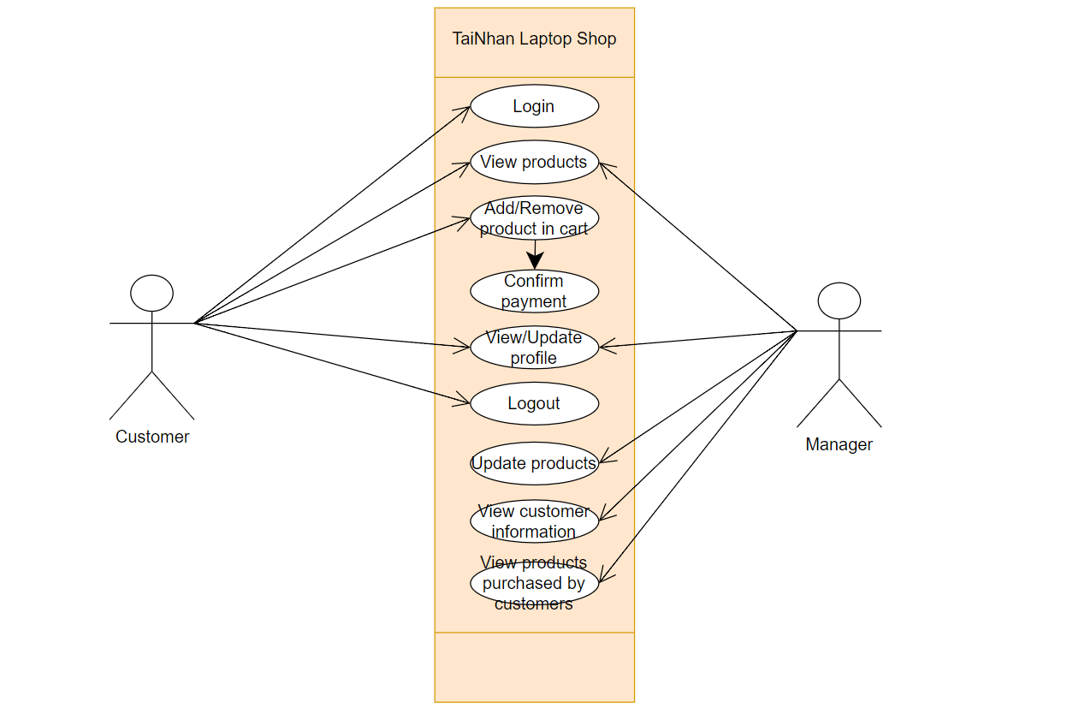

Figure 2: Use case diagram

As you can see in Figure 2, TaiNhan Laptop Shop's Use Case Diagram has shown the website roles including Customer and Administrator role. Customers will be able to login, log out of the account registered with the store, view products, add or remove products from the cart, pay, view or change their profile. Managers can view products, view or change customer profiles, add products and view purchased products.

### Wireframes

### Home page

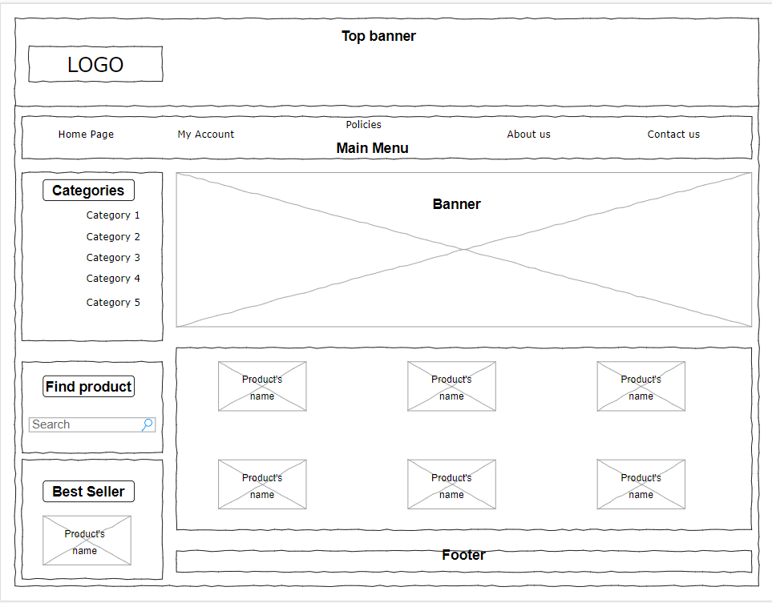

Figure 3: Wireframe of Homepage

The parts on the home page are as follows:

* **Top banner:** The top banner has the shop's logo. When the user wants to return to the homepage, just click on the shop's logo, they can return to the homepage immediately.
* **Main menu:** Integrate Home page, My Account, Policies, About us and Contact us. Let people browse between pages using tags with related titles.
* **Banner:** Display promotions, shop events on the website
* **Product information:** Images, names, and prices for items in the aforementioned categories are provided. Customers can also add items to their shopping carts.
* **Categories:** The classification's name.
* **Find product:** where you can search for products in the shop
* **Best Seller:** Suggest products that many customers buy at the shop
* **Footer:** I've given my contact information in case clients need assistance.

## Login Page

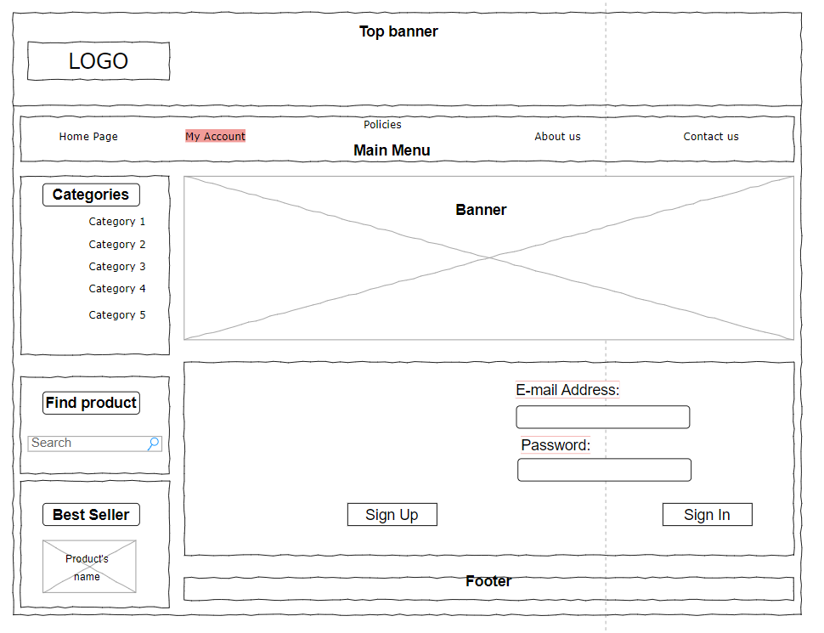

Figure 4: Wireframe of Login page

* To be able to log in to your account, you must select "***My Account***" in the Main Menu
* You just need to enter the email and password that have been registered before to use, then select "***Sign In***"
* Customers who have not yet registered an account can do this by going to the account registration page and selecting "***Sign Up***".

### Sign Up Page

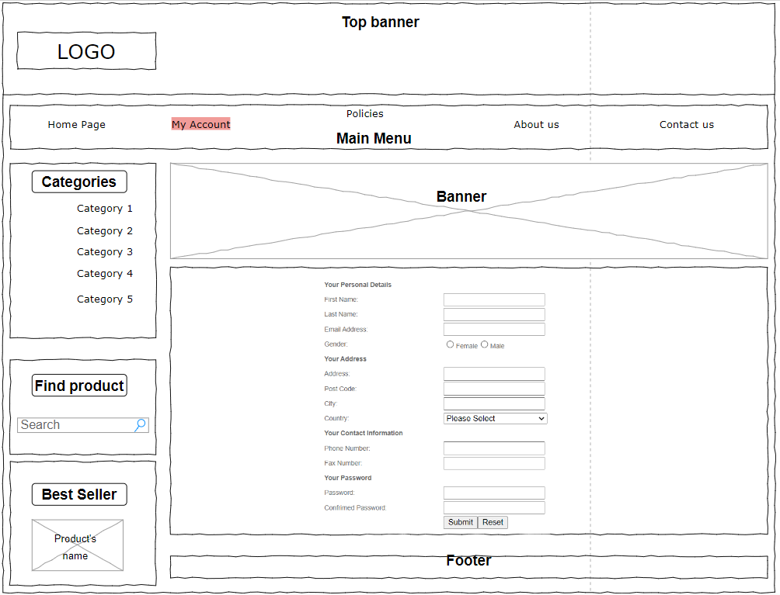

Figure 5: Sign Up page

* The interface of the login page is the same as that of the registration page, although the registration form has additional fields for the user to fill out.
* What customers need to fill in First Name, Last Name, Email Address, Gender, Address, Post Code, City, Country, Phone Number, Fax Number, Password and Confirmed Password. After entering all information, the customer clicks "***Submit***" to complete the registration. If the customer does not want to register the information just entered, then click "***Reset***" to delete all the information just entered.

### Profile

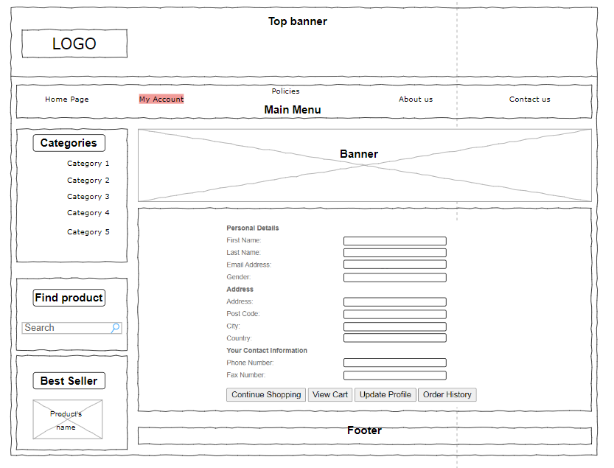

Figure 6: Wireframe of Profile page

* After logging in, the website will display all the information that the customer has registered.
* From there customers can choose to "continue shopping", "view cart", "update profile" or "Order history"

### View Cart Page

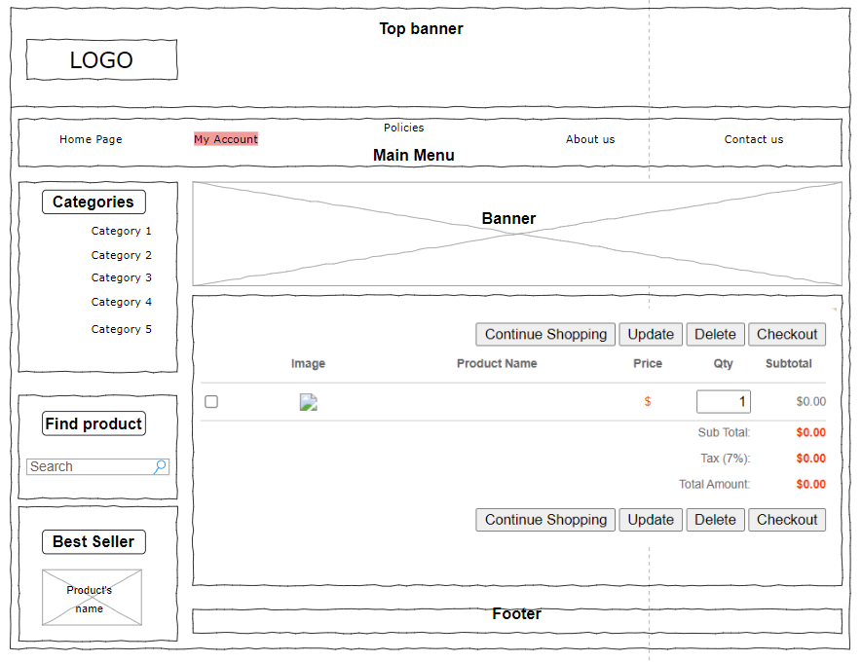

Figure 7: View Cart Page

* User can easily switch between pages
* On this page, customers can see the items they have in their cart as well as the total amount of their order.
* In addition, when the products are added to the customer's cart, the customer can click on the box to the left of the product to determine whether to buy it or not or add or subtract the quantity of each product.

### Update Profile Page

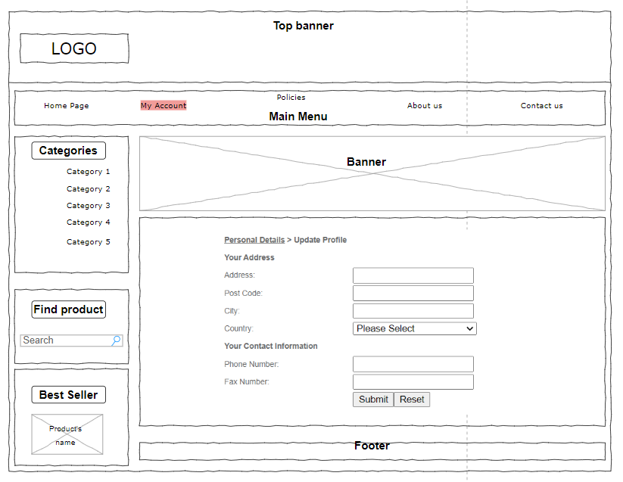

Figure 8: Update Profile Page

* Customers need to change their profile, then select "Update Profile" to change.
* By selecting the “Submit” button below, customers may save the changes after making necessary changes to the data or changing the password in these areas.

## Sitemap

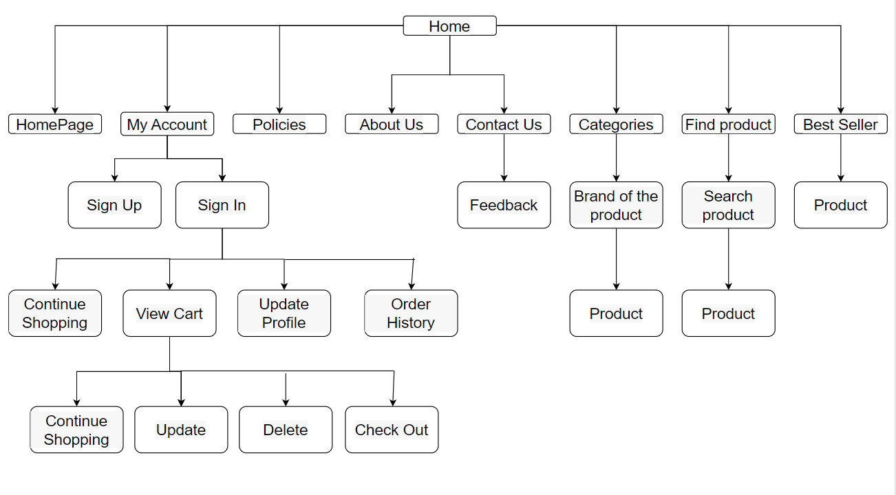

Figure 9: Website diagram

The sitemap you see up there is one I made for development.

* To make it clear to customers which things are for sale, I will showcase each one in the store. To aid customers in making the best decision possible
* When customers have questions or complaints about the shop, they can give feedback to the shop so that the shop can answer and support the customer as best as possible.
* There will be a Profile page on the website to help users and management comprehend user information. Private information about the customer is kept here. The ownership of a customer's personal information is entirely theirs. The "Update Profile" page is directed to them so they may edit their information.
* In the "View Cart" section, customers can "update" the products they choose or "delete" the products they don't want to buy. Finally, you can click "Check Out" so that the shop staff can assist customers with payment methods. In addition, customers can go to the "Other History" section to see the products they have purchased in the past.

# USE YOUR DESIGN DOCUMENT WITH APPROPRIATE PRINCIPLES, STANDARDS AND GUIDELINES TO PRODUCE A BRANDED, MULTIPAGE WEBSITE SUPPORTED WITH REALISTIC CONTENT (P6)

## Source code Samples of the Website

* **aboutus.php:**

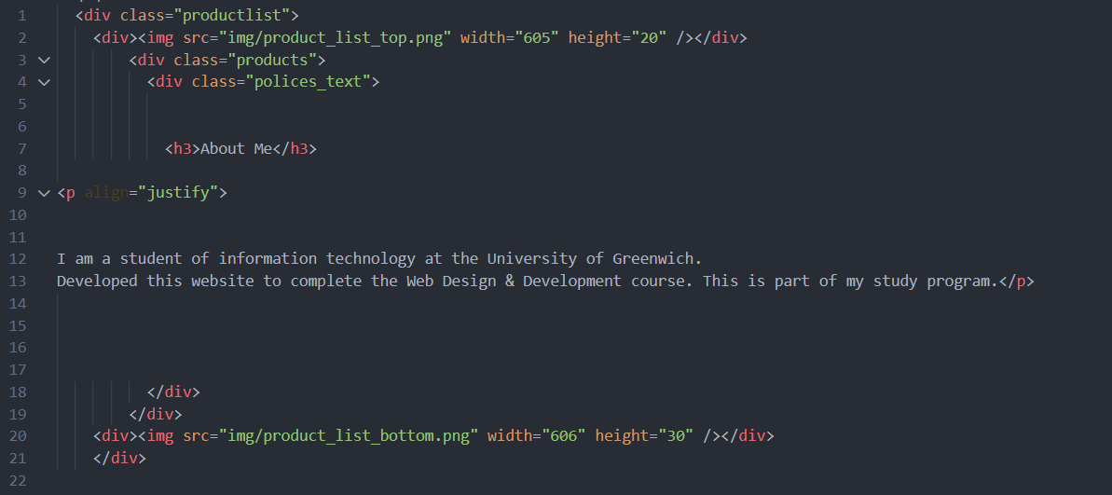

Figure 10: aboutus.php

* **addcart.php:**

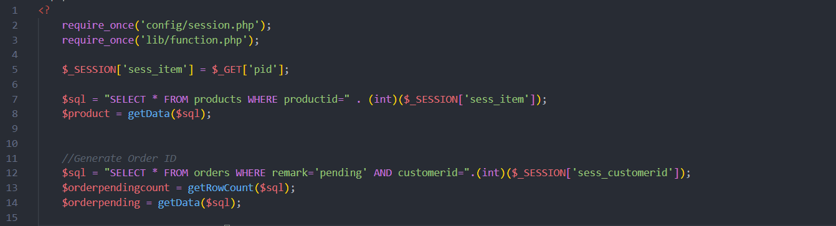

Figure 11: addcart.php (1)

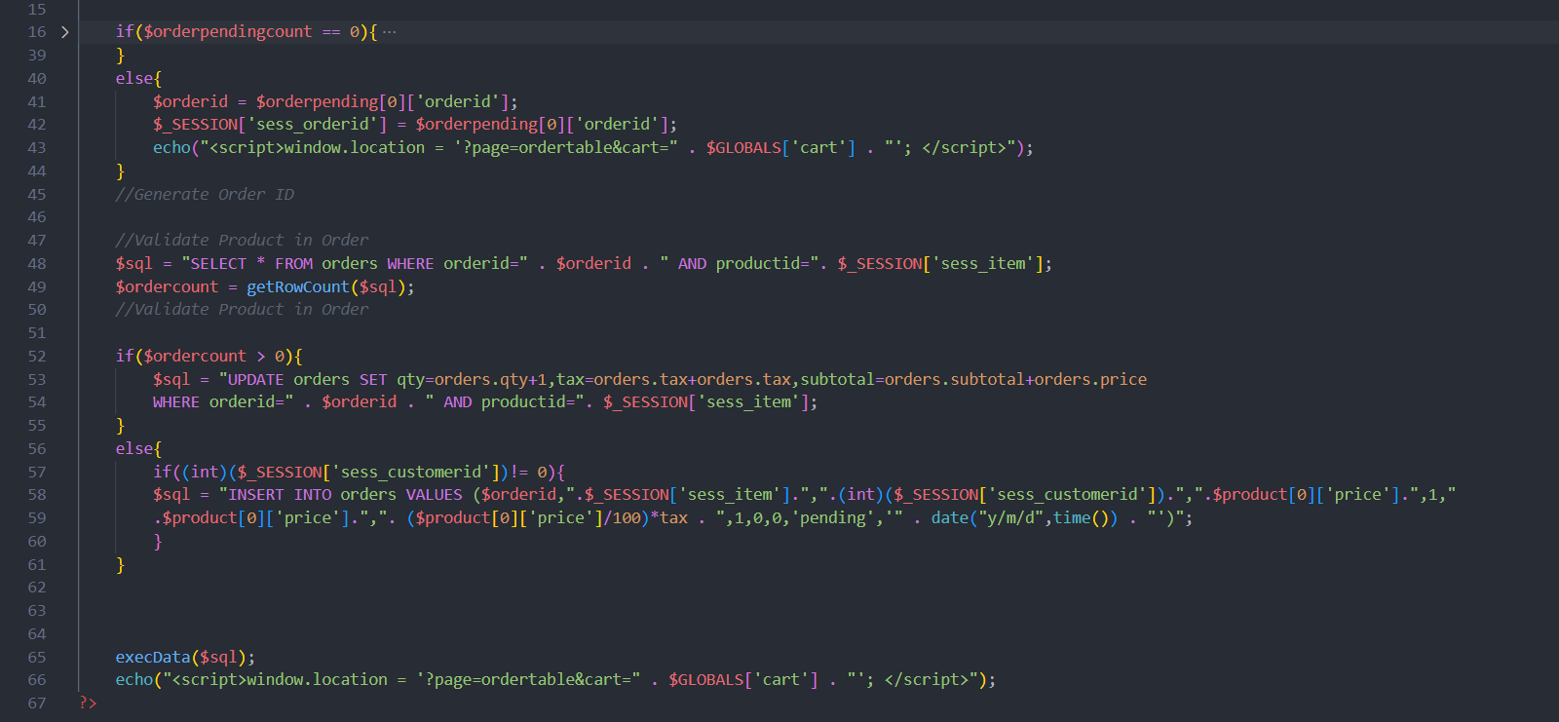

Figure 12: addcart.php (2)

* **categories.php:**

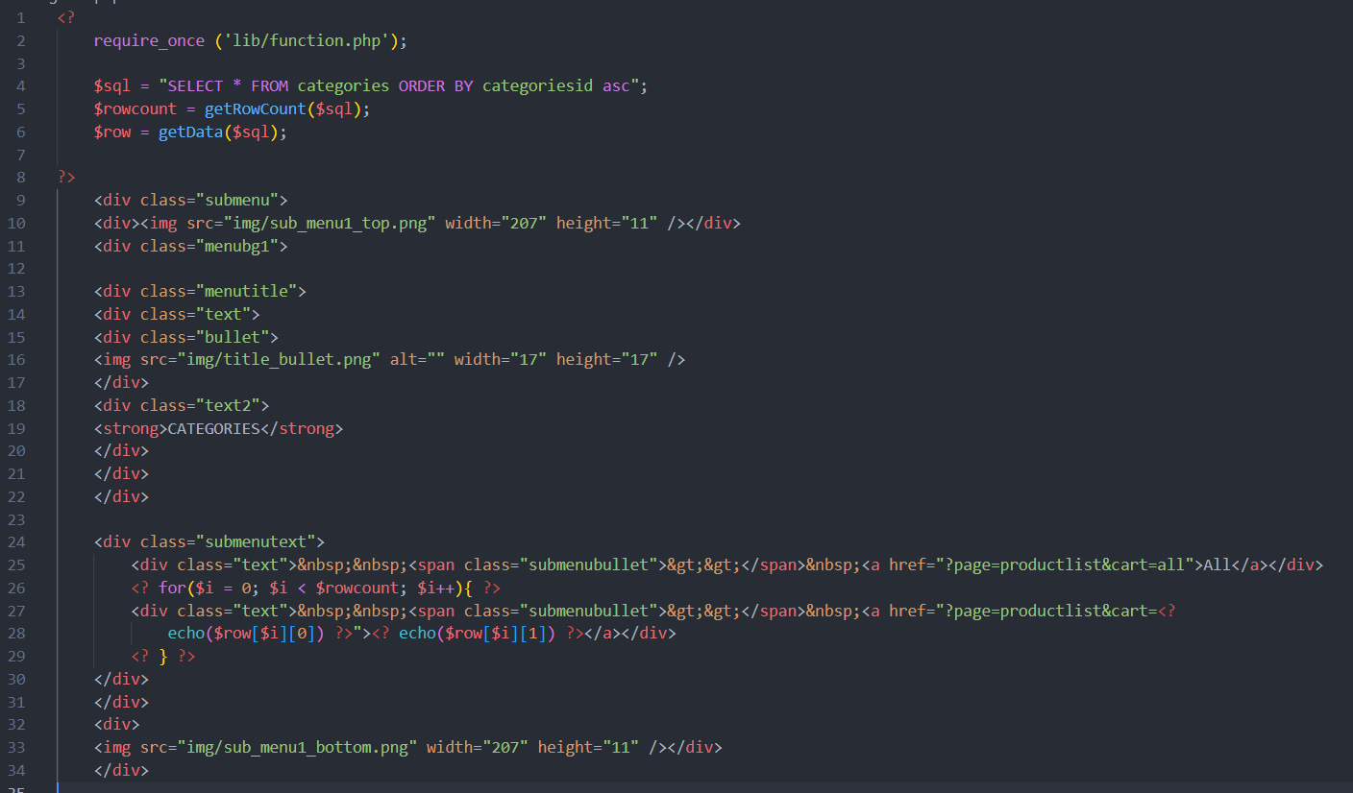

Figure 13: categories.php

* **complete.php:**

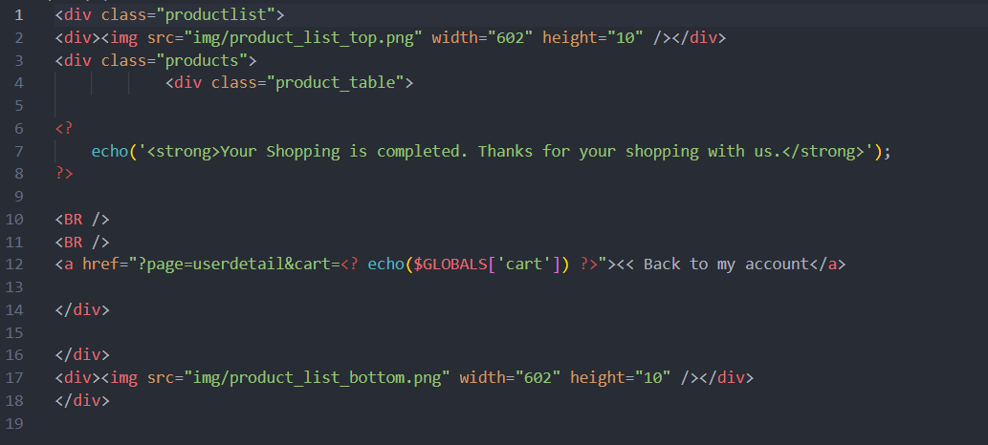

Figure 14: complete.php

* **contact.php:**

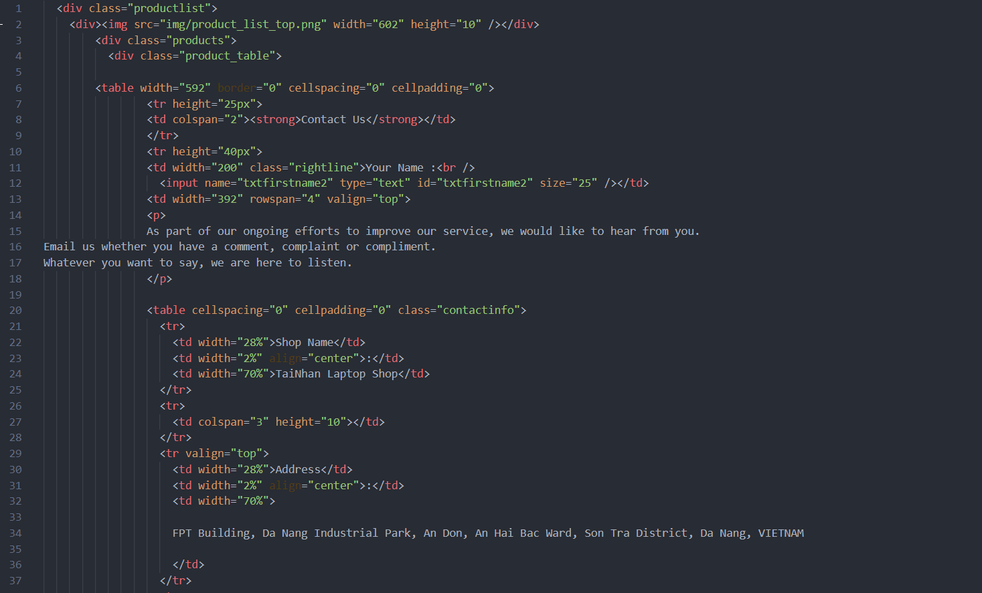

Figure 15: contact.php (1)

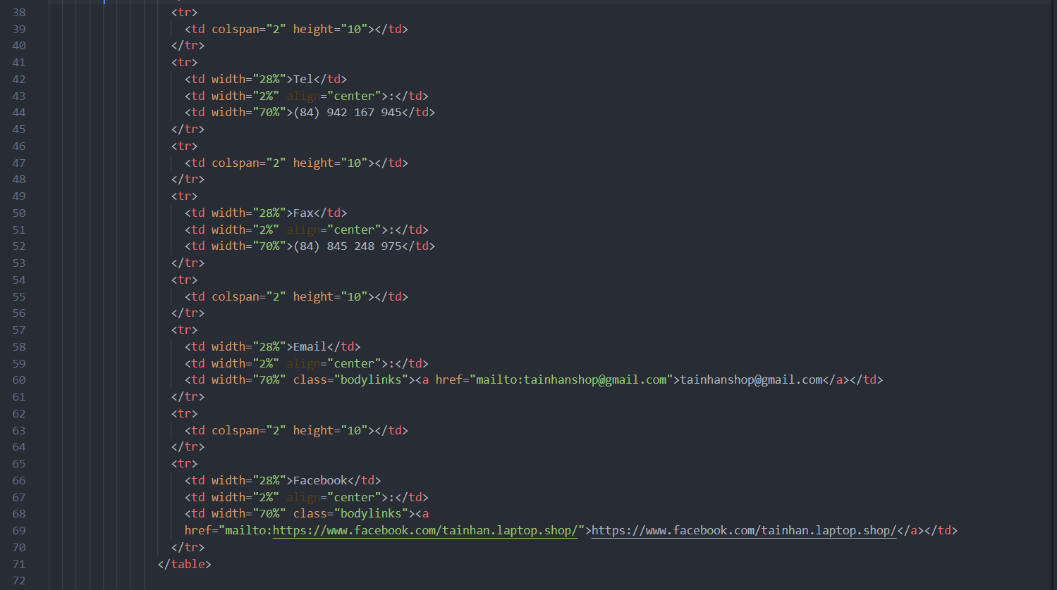

Figure 16: contact.php (2)

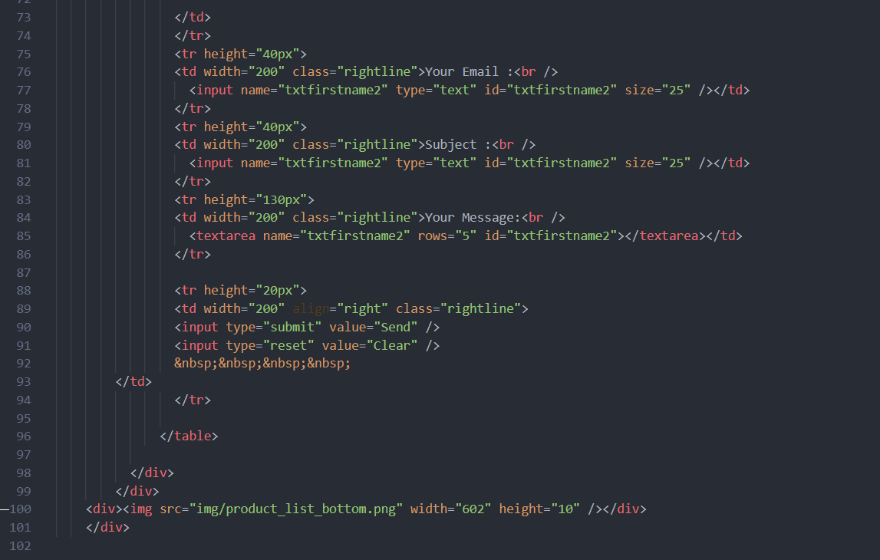

Figure 17: contact.php (3)

* **finish.php:**

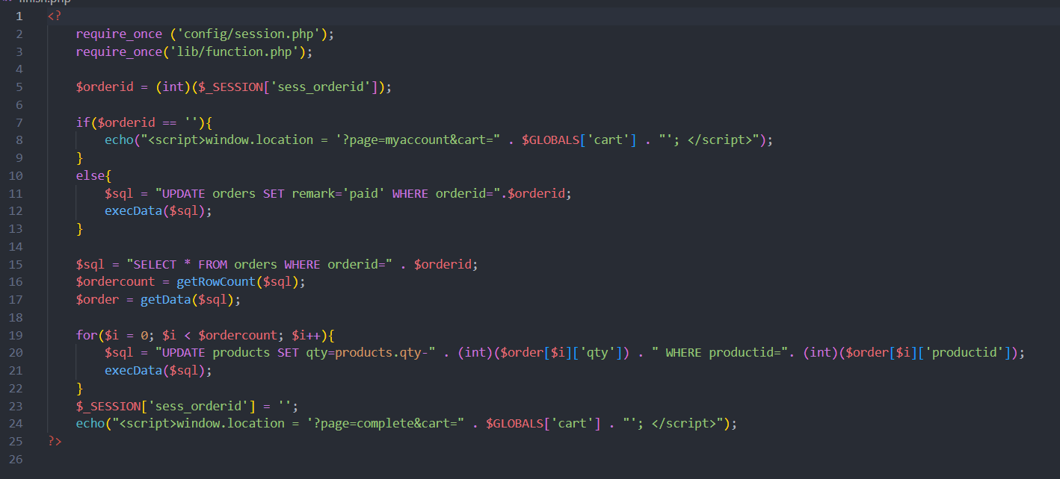

Figure 18: finish.php

* **footer.php:**

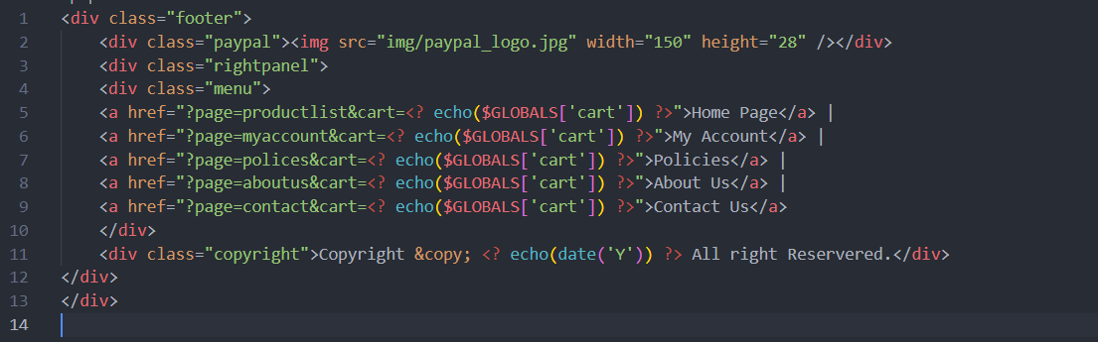

Figure 19: footer.php

* **index.php:**

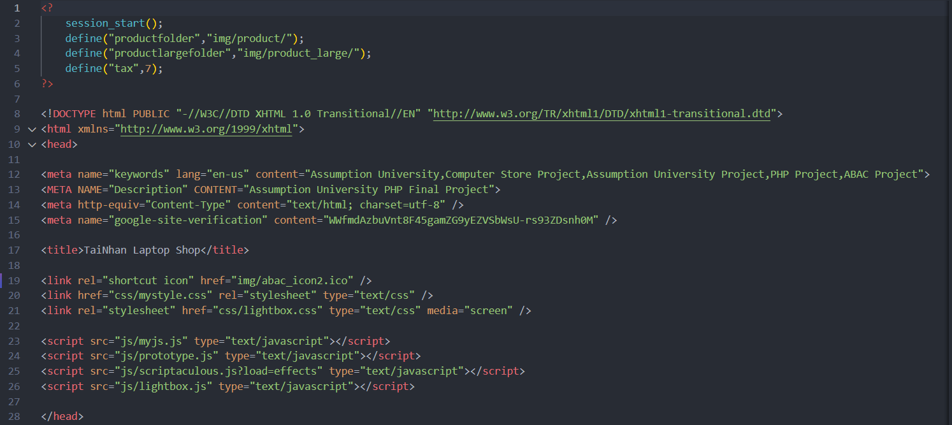

Figure 20: index.php (1)

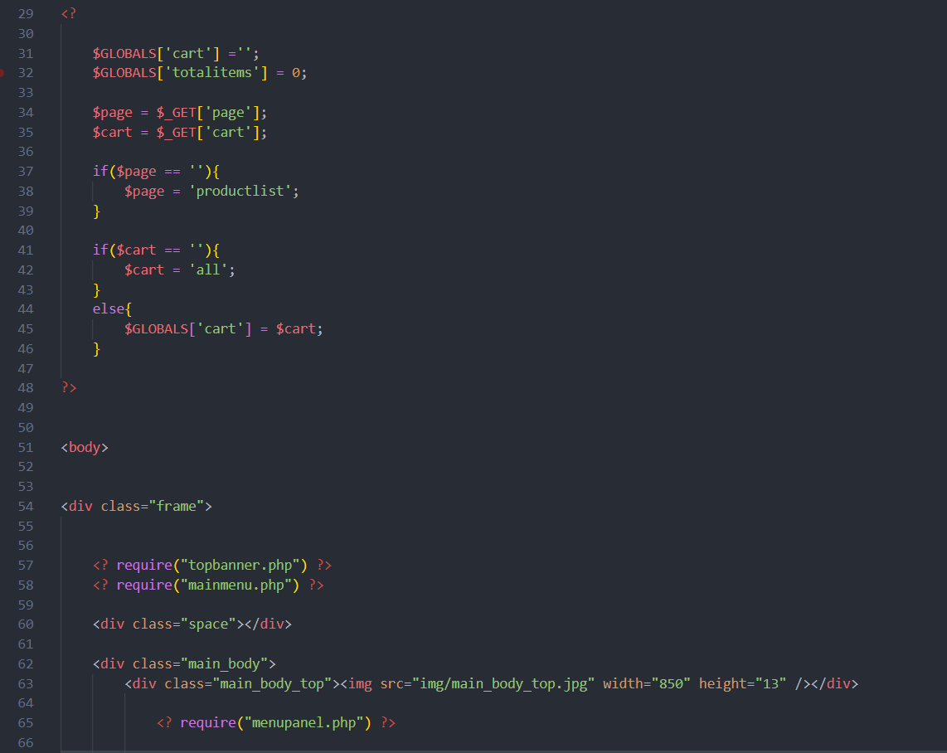

Figure 21: index.php (2)

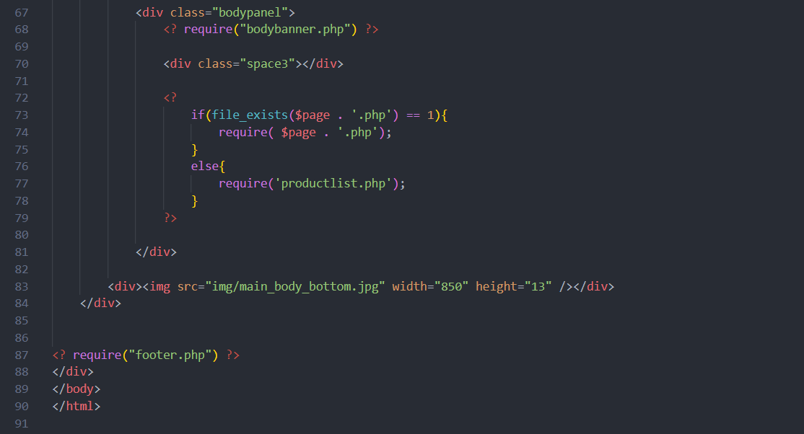

Figure 22: index.php (3)

* **invoice.php:**

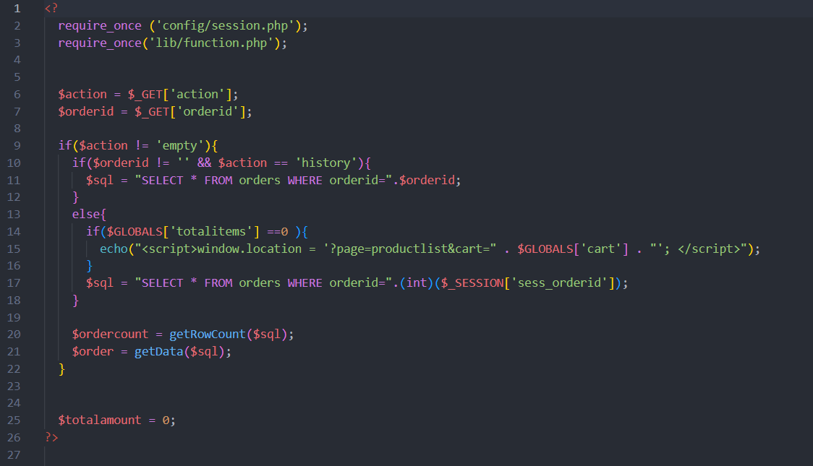

Figure 23: invoice.php (1)

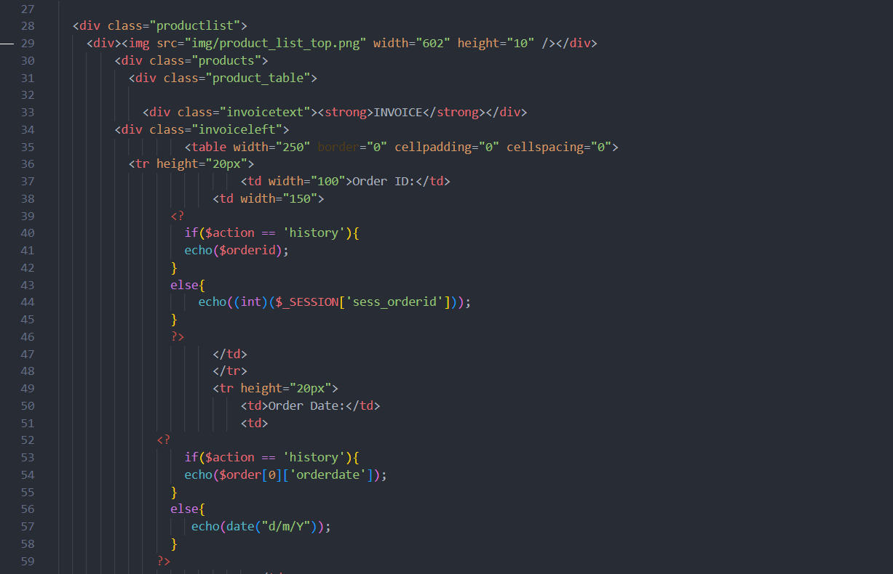

Figure 24: invoice.php (2)

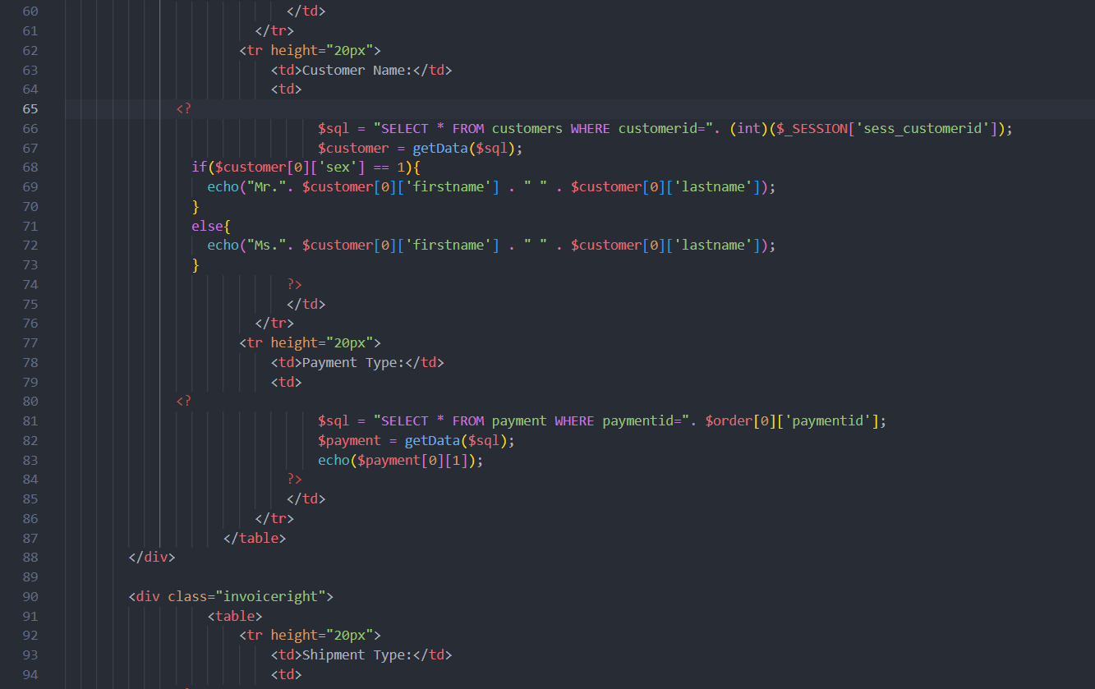

Figure 25: invoice.php (3)

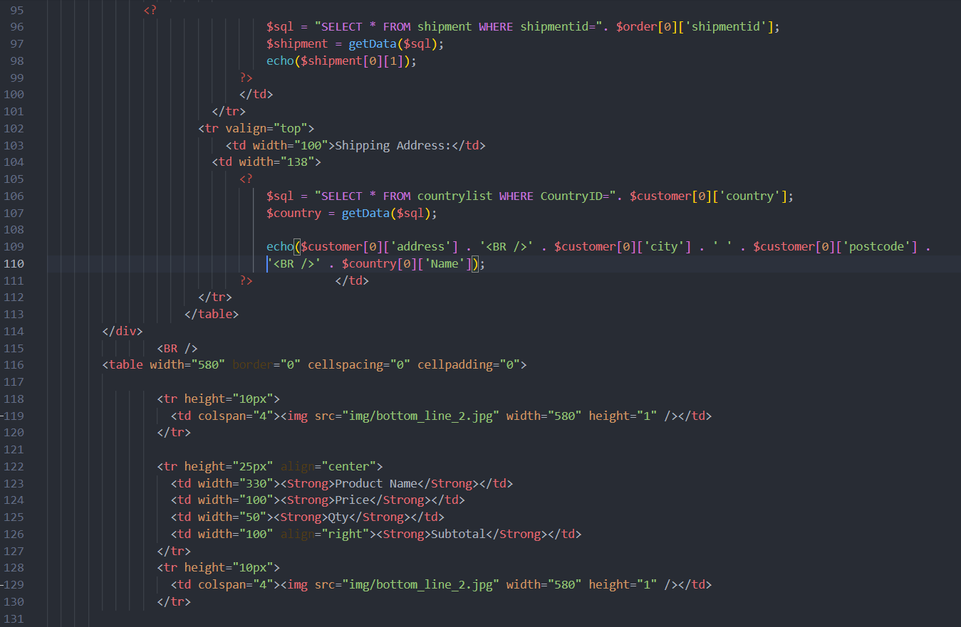

Figure 26: invoice.php (4)

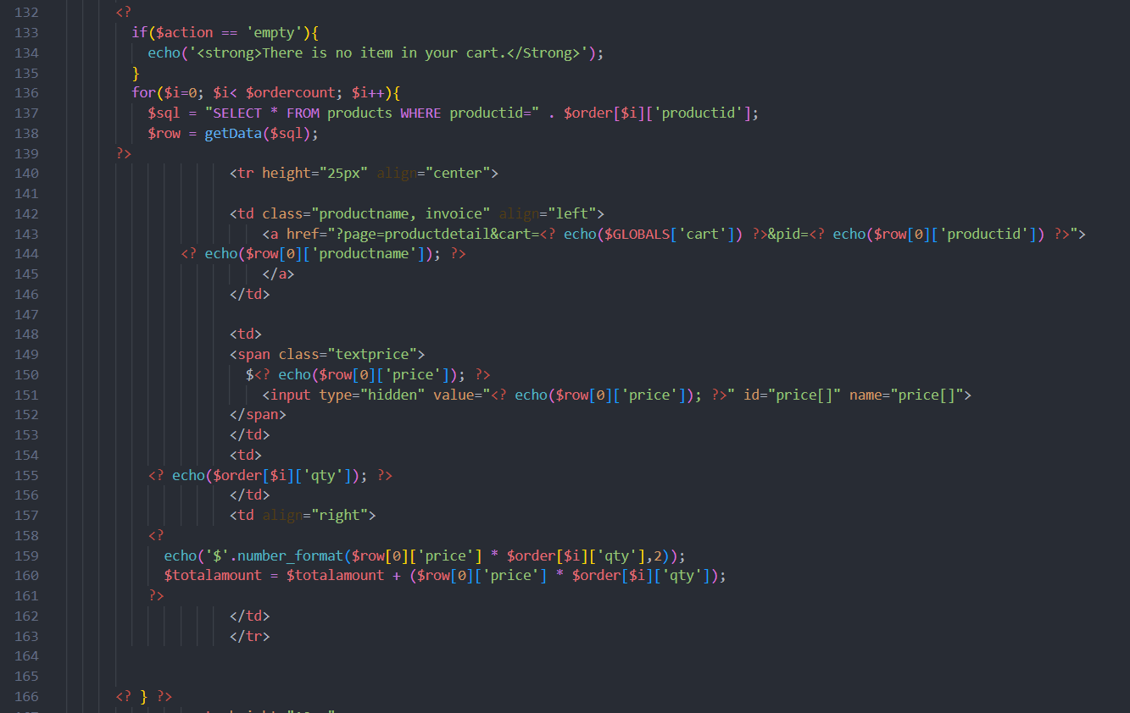

Figure 27: invoice.php (5)

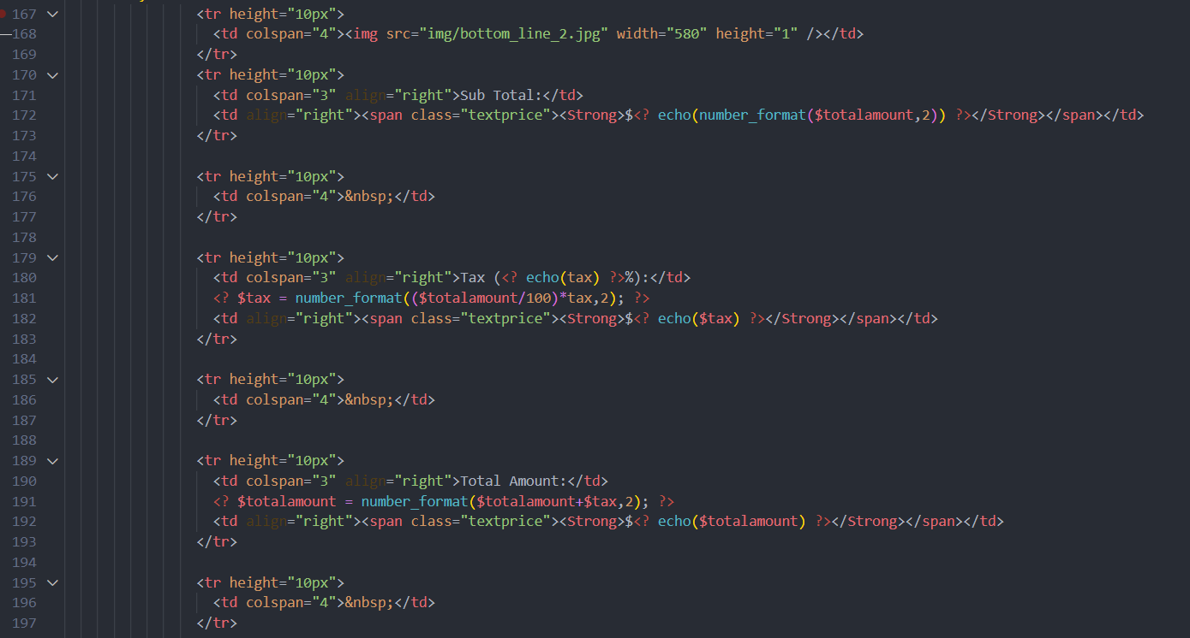

Figure 28: invoice.php (6)

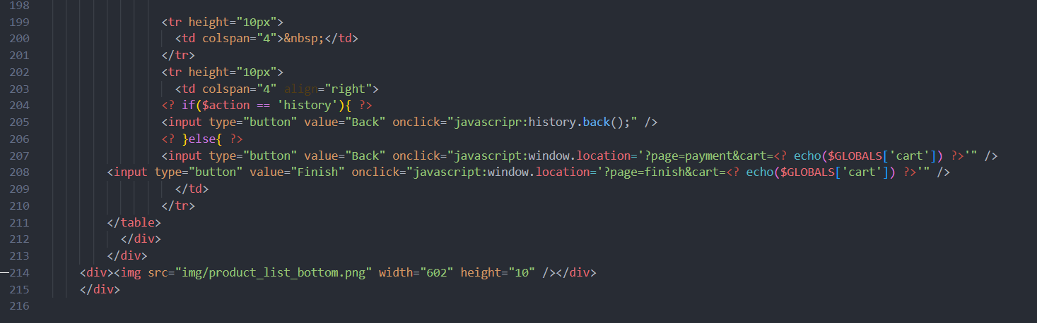

Figure 29: invoice.php (7)

* **login.php:**

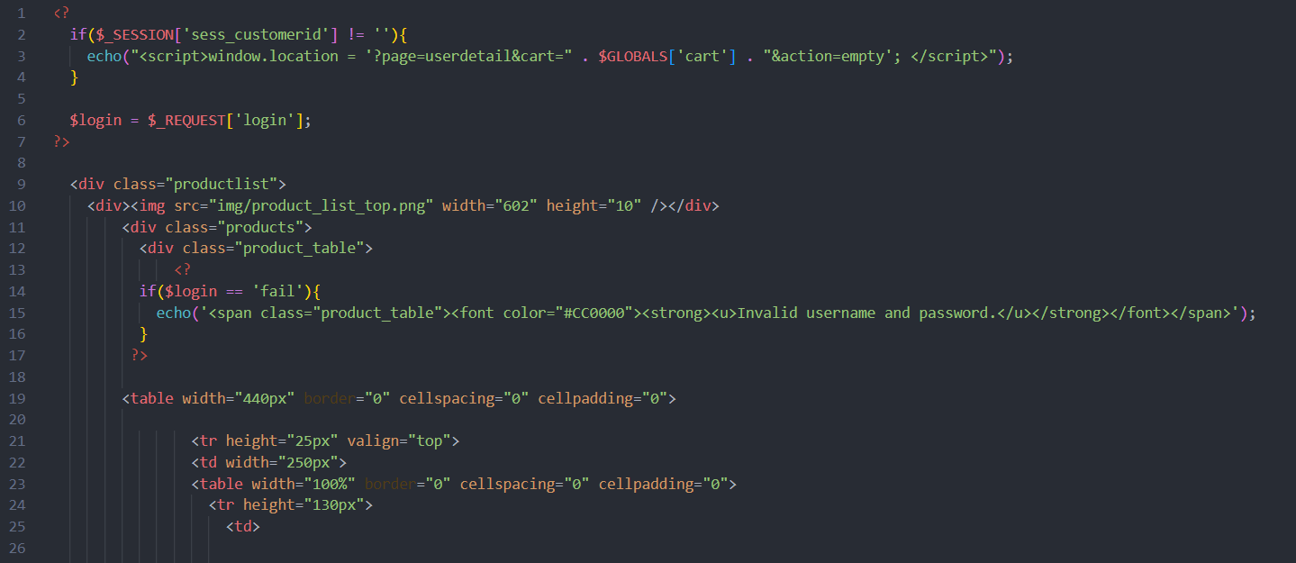

Figure 30: login.php (1)

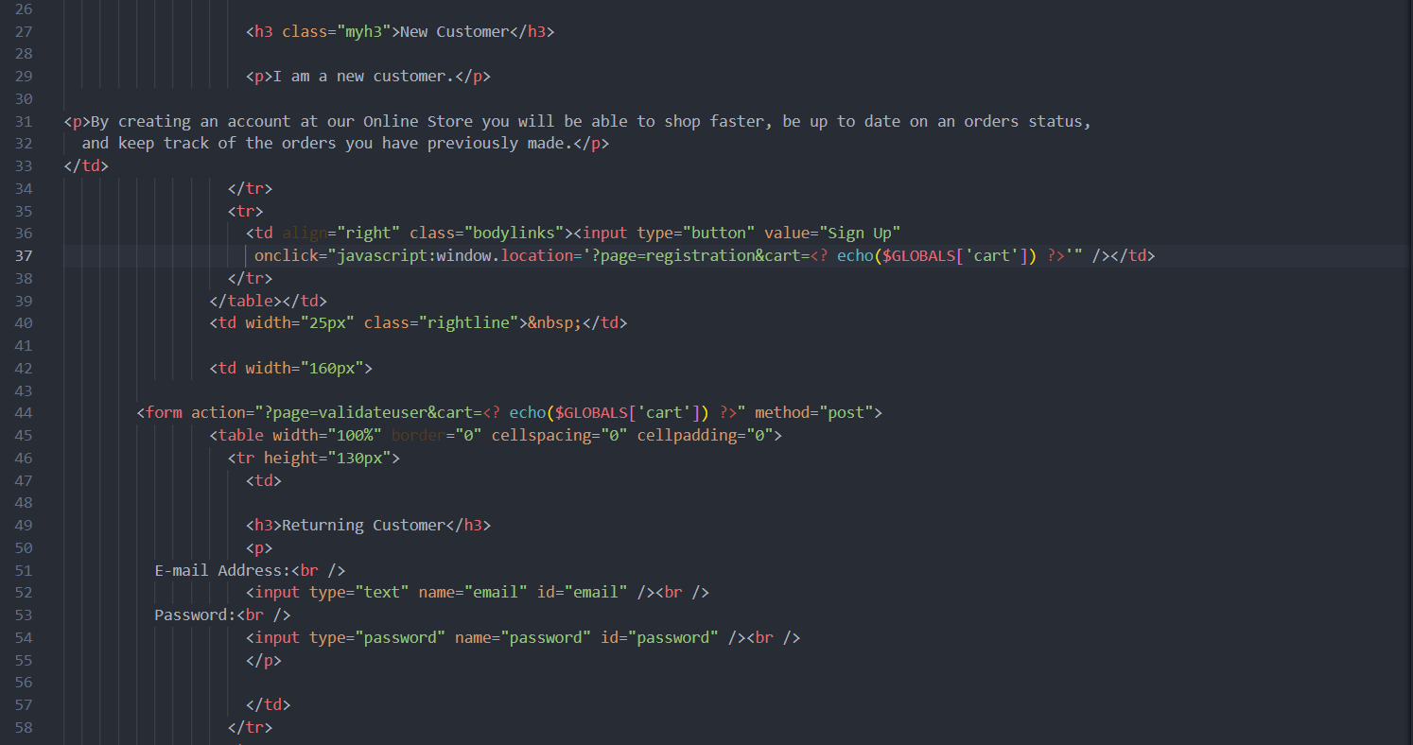

Figure 31: login.php (2)

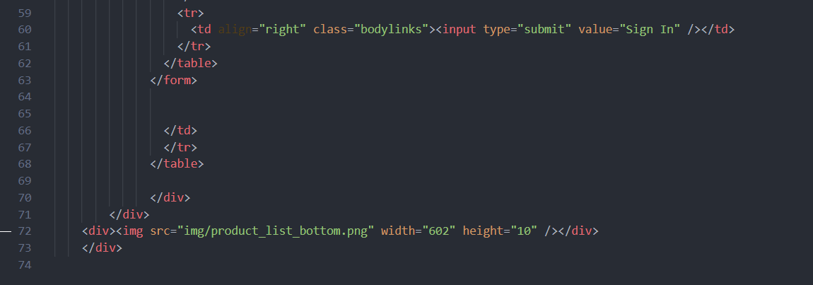

Figure 32: login.php (3)

* **logout.php:**

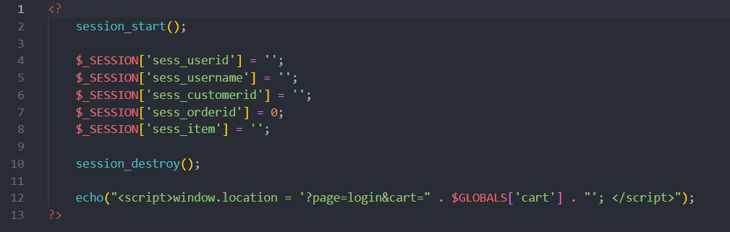

Figure 33: logout.php

* **mainmenu.php:**

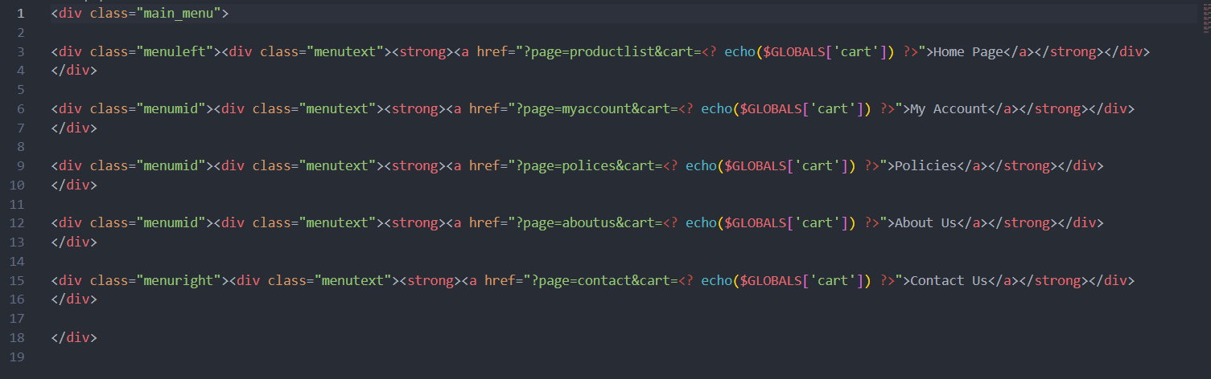

Figure 34: mainmenu.php

* **menupanel.php:**

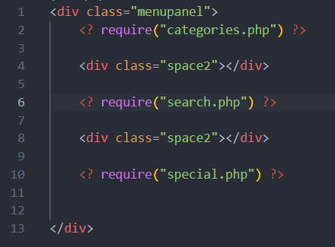

Figure 35: menupanel.php

* **myaccount.php**

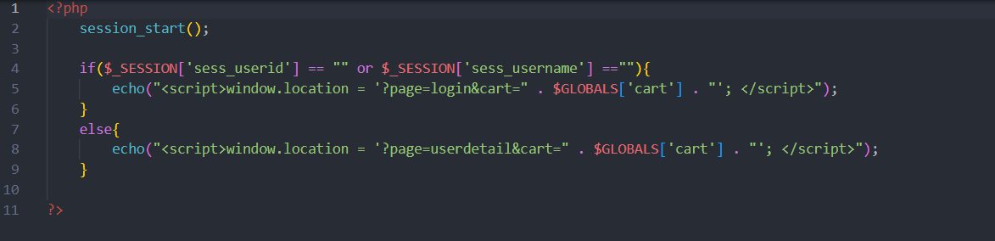

Figure 36: myaccount.php

* **orderdelete.php:**

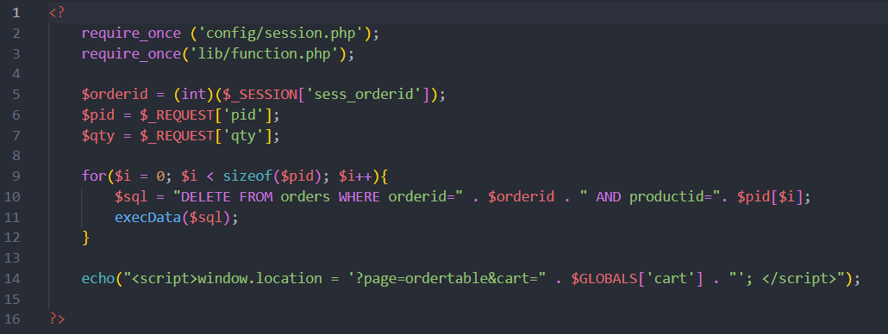

Figure 37: orderdelete.php

* **orderhistory.php:**

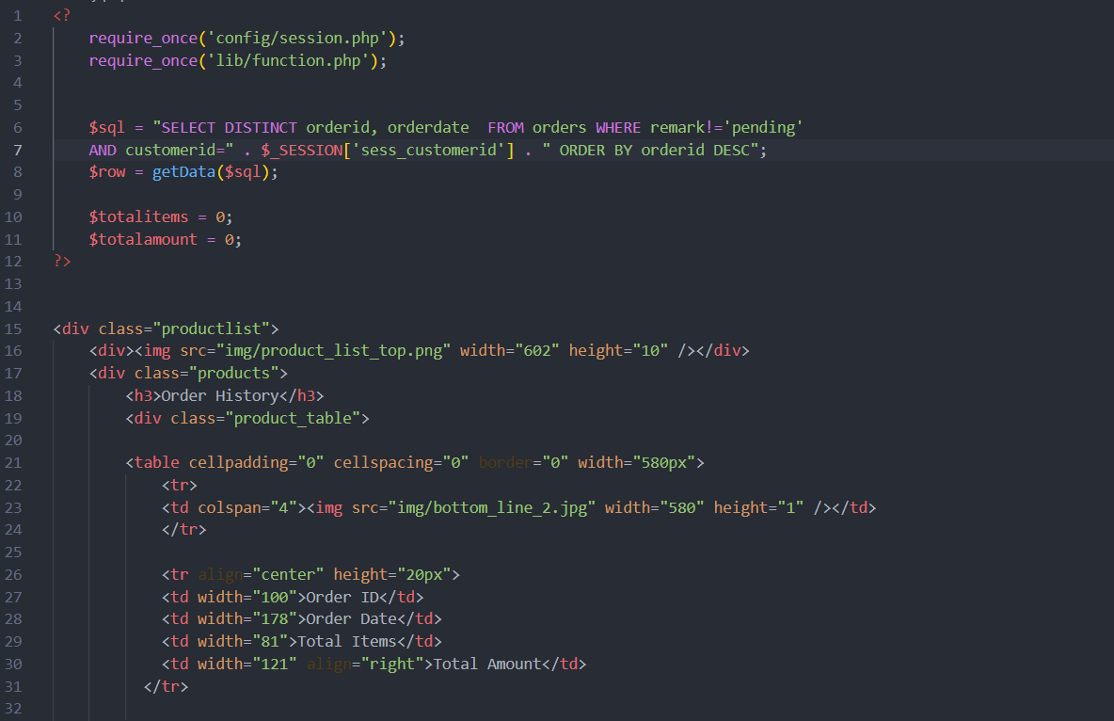

Figure 38: orderhistory.php (1)

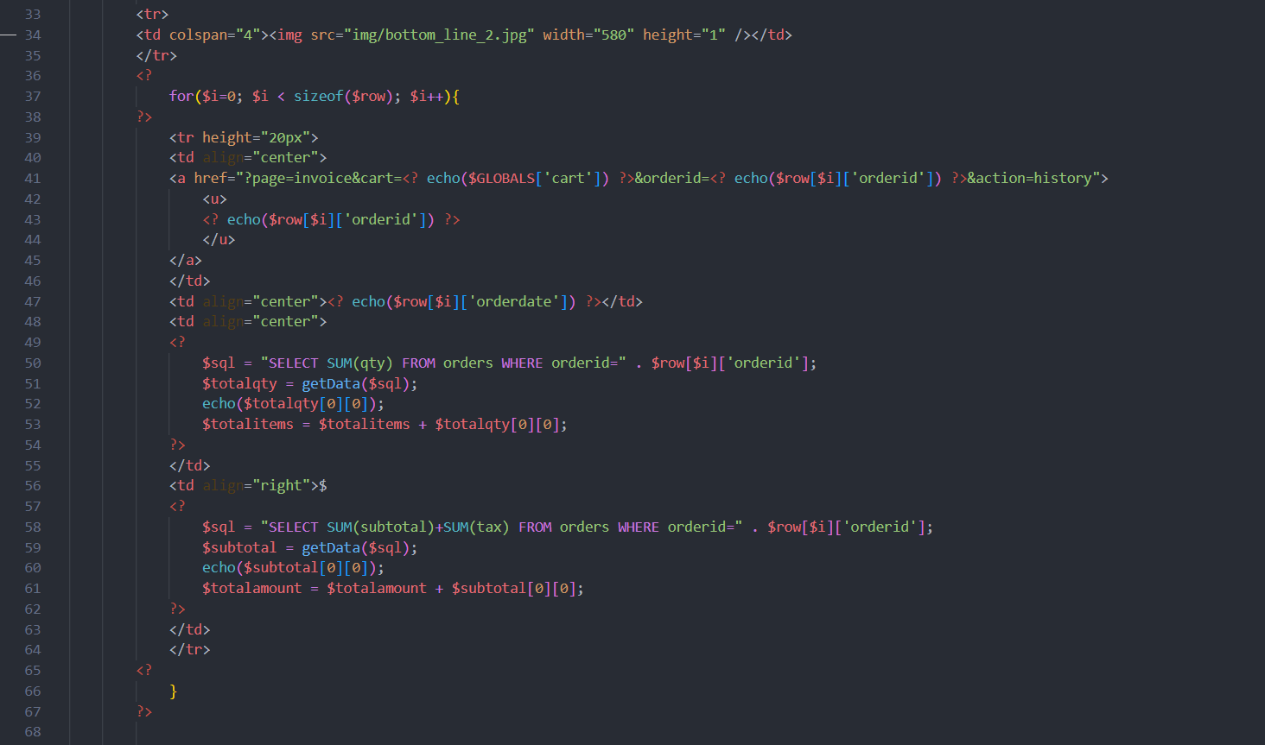

Figure 39: orderhistory.php (2)

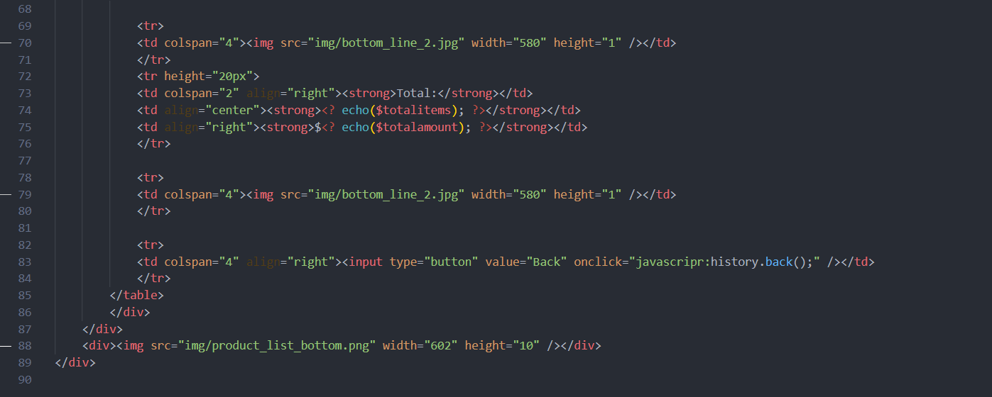

Figure 40: orderhistory.php (3)

* **ordertable.php**

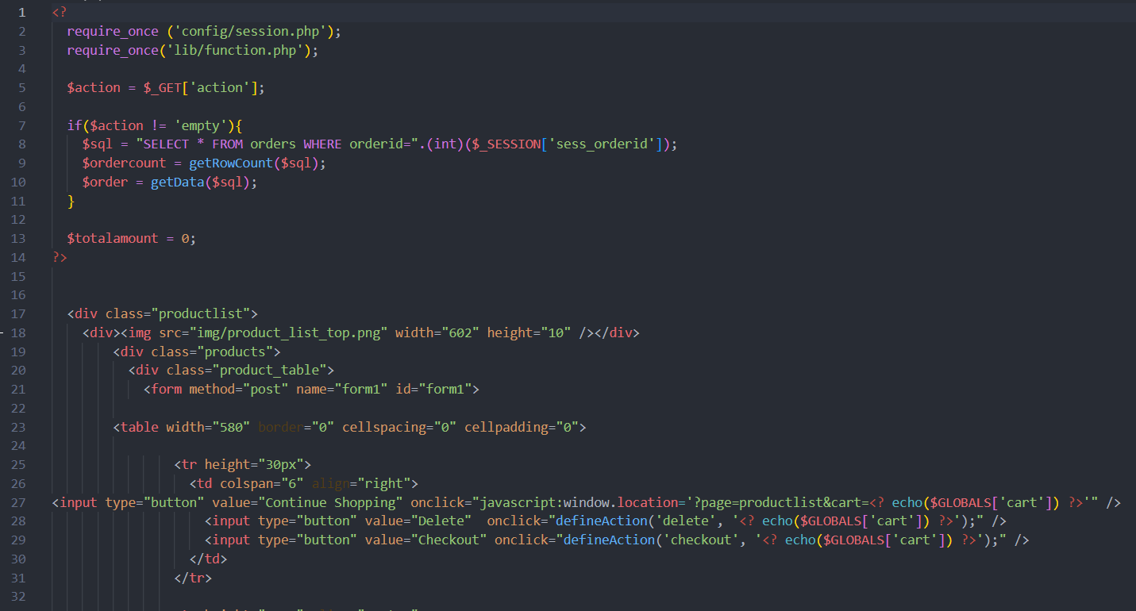

Figure 41: ordertable.php (1)

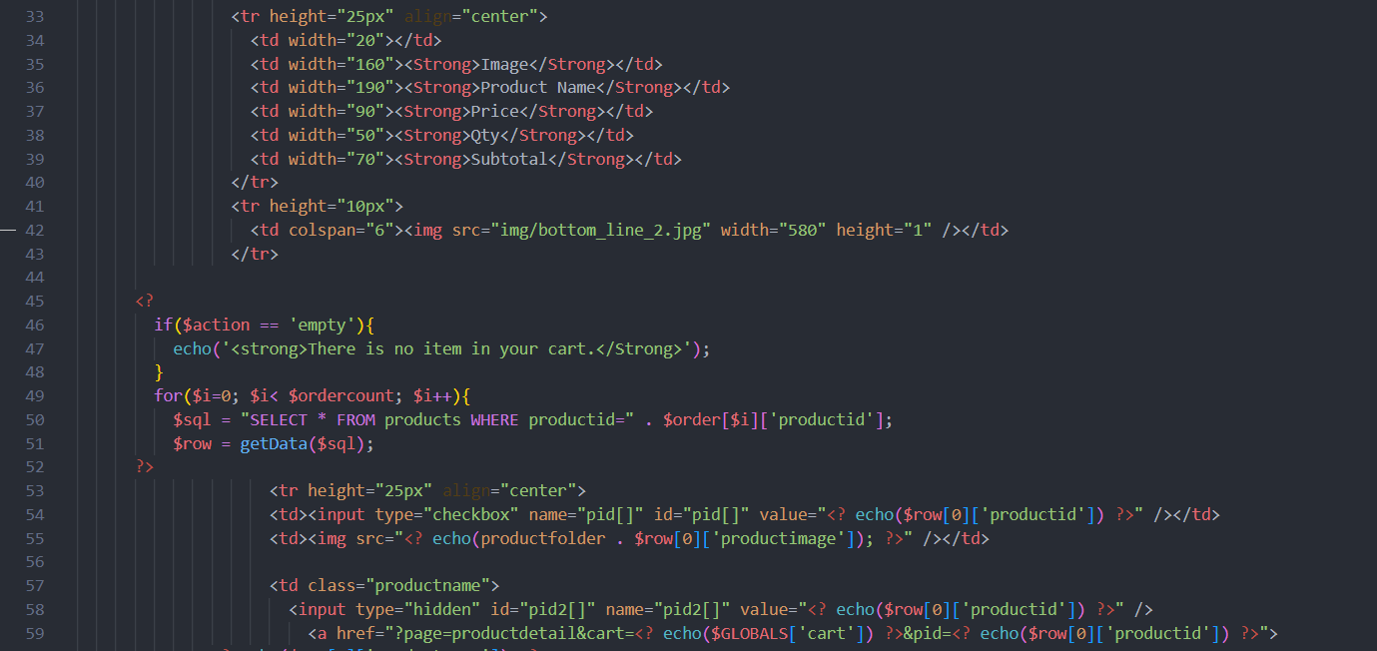

Figure 42: ordertable.php (2)

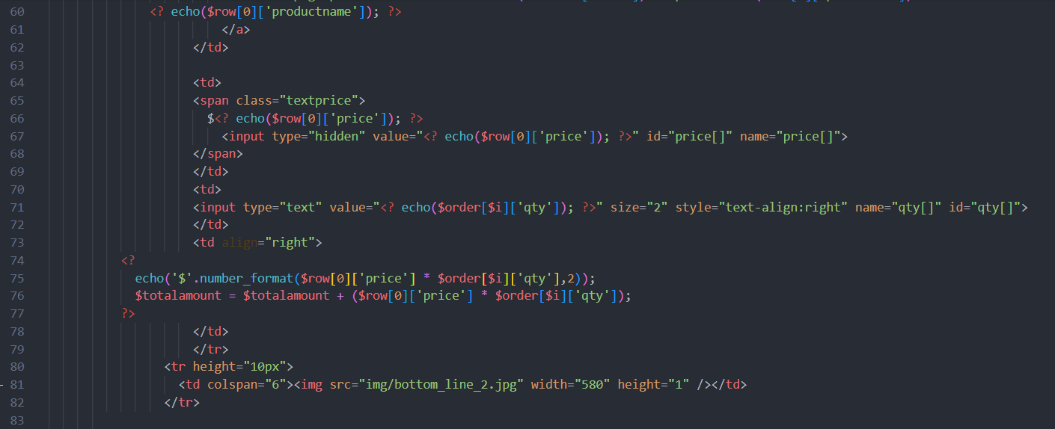

Figure 43: ordertable.php (3)

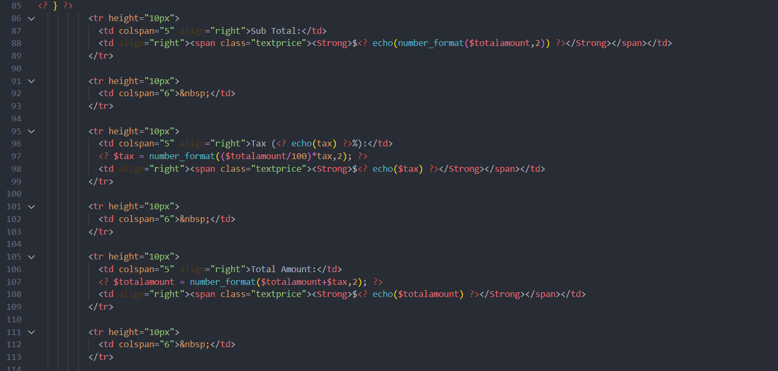

Figure 44: ordertable.php (4)

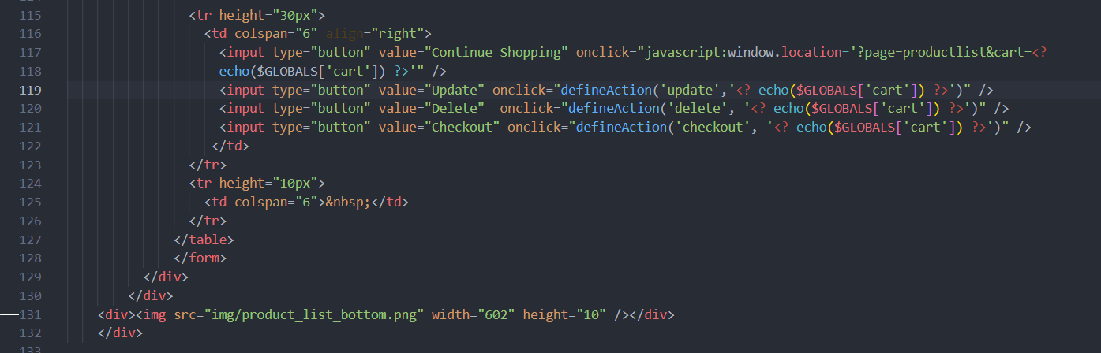

Figure 45: ordertable.php (5)

* **orderupdate.php**

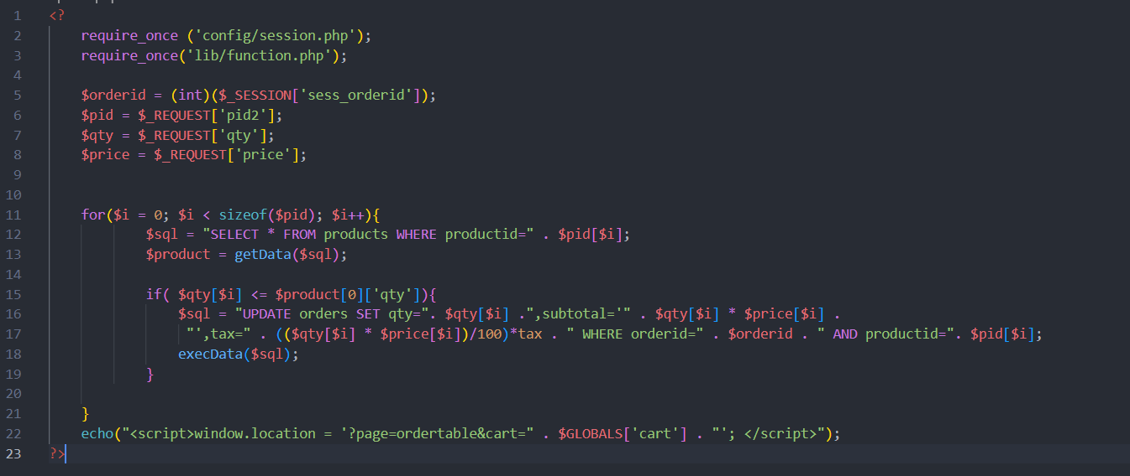

Figure 46: orderupdate.php

* **payment.php:**

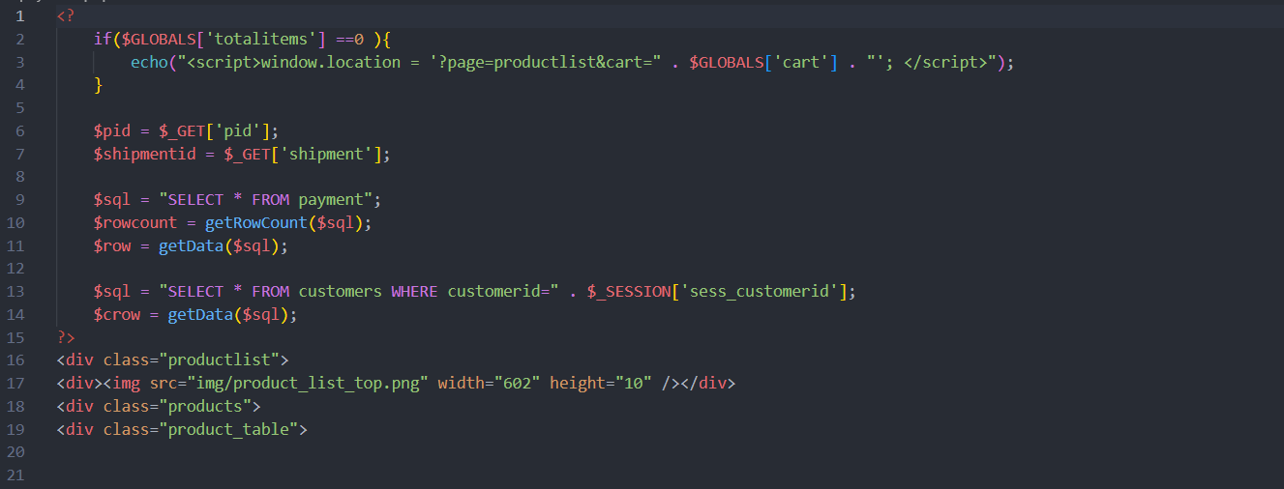

Figure 47: payment.php (1)

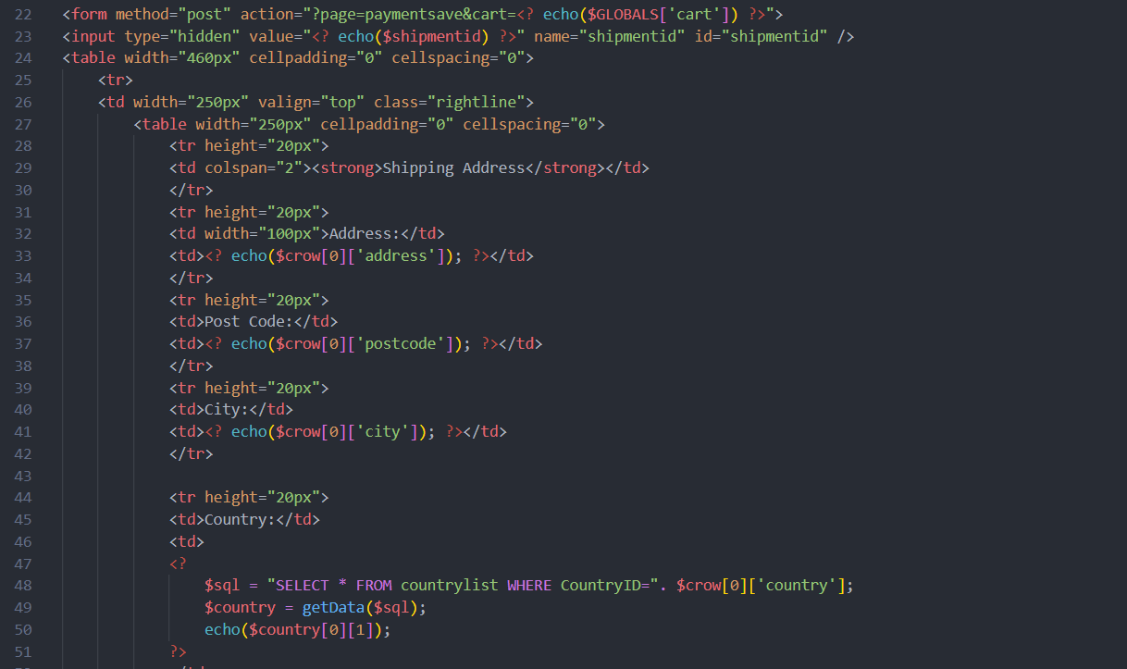

Figure 48: payment.php (2)

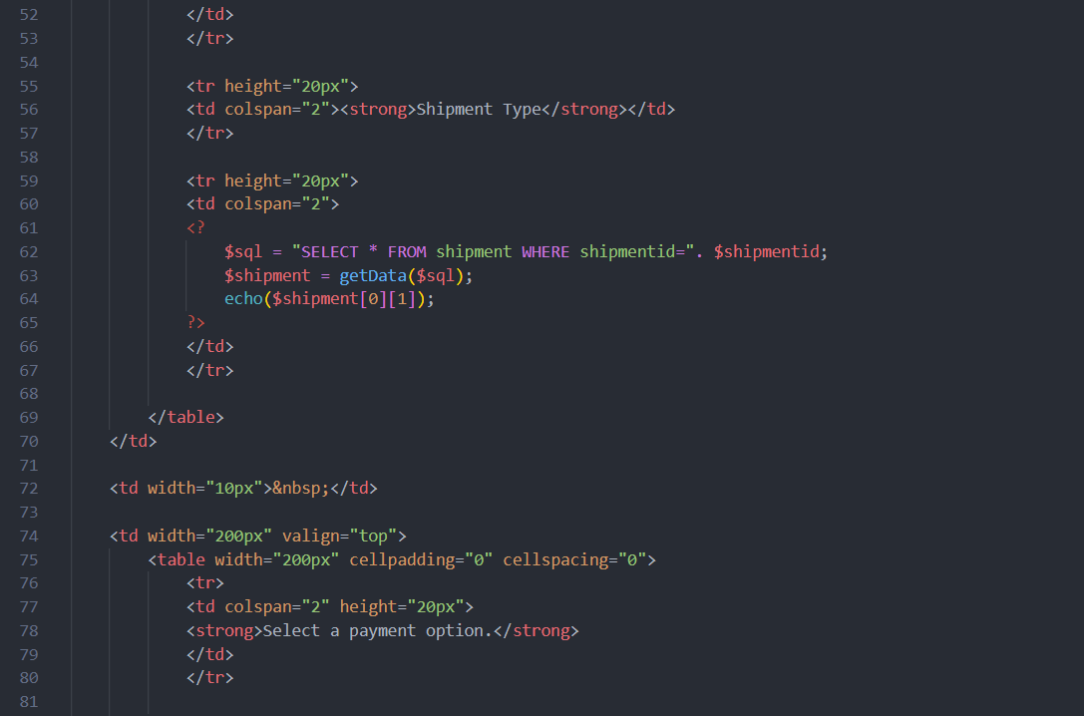

Figure 49: payment.php (3)

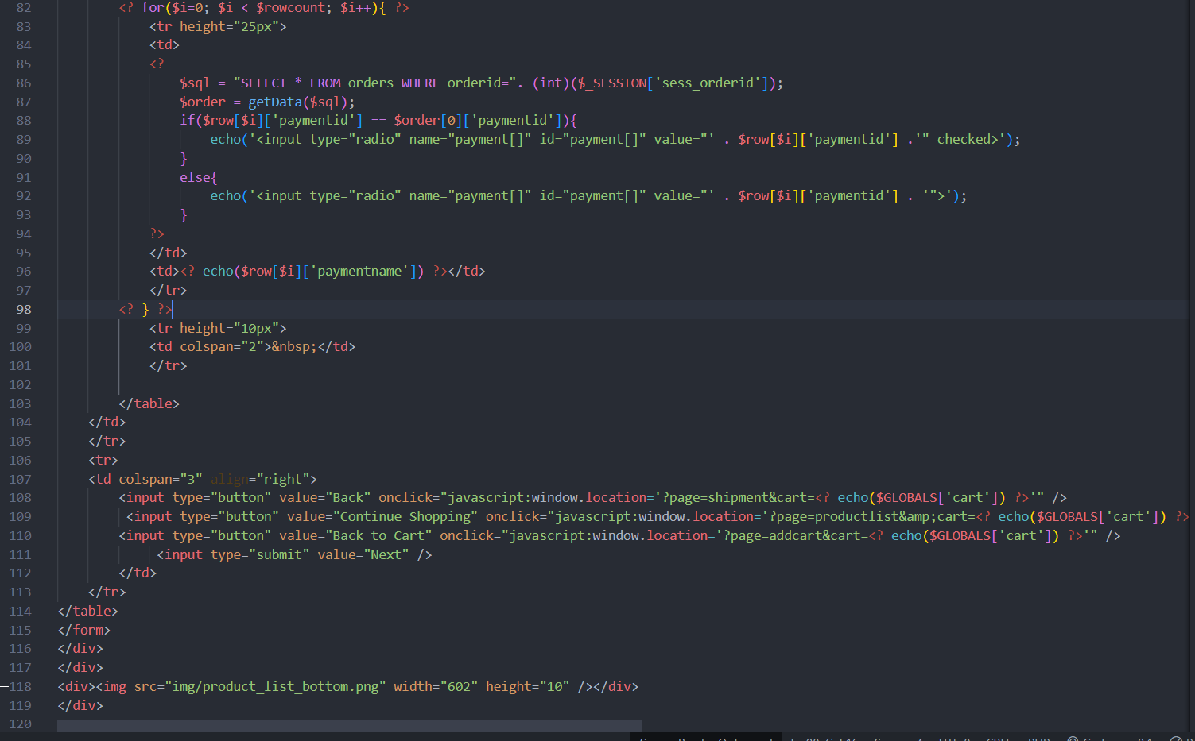

Figure 50: payment.php (4)

* **paymentsave.php**

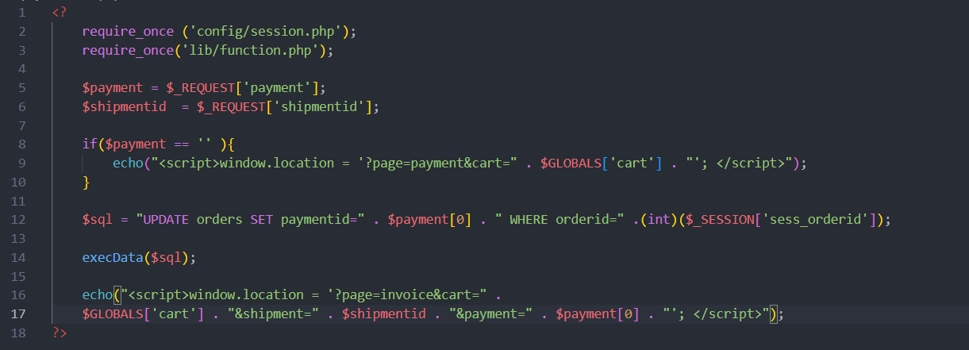

Figure 51: paymentsave.php

* **policies.php:**

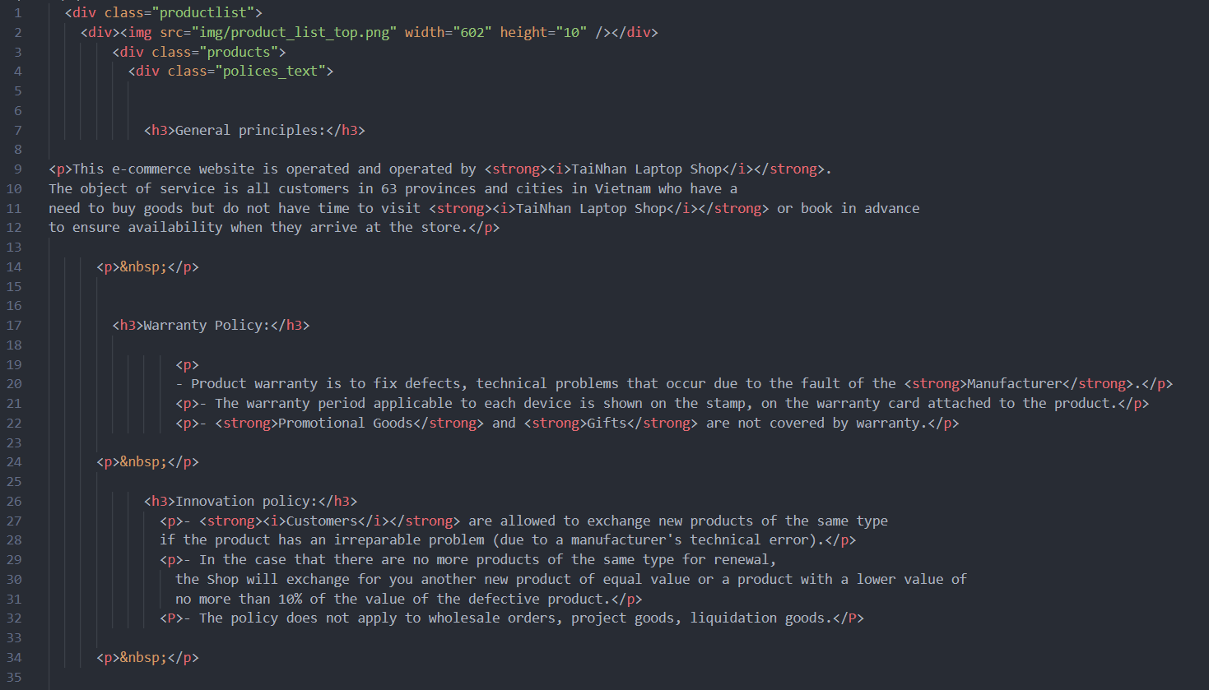

Figure 52: policies.php (1)

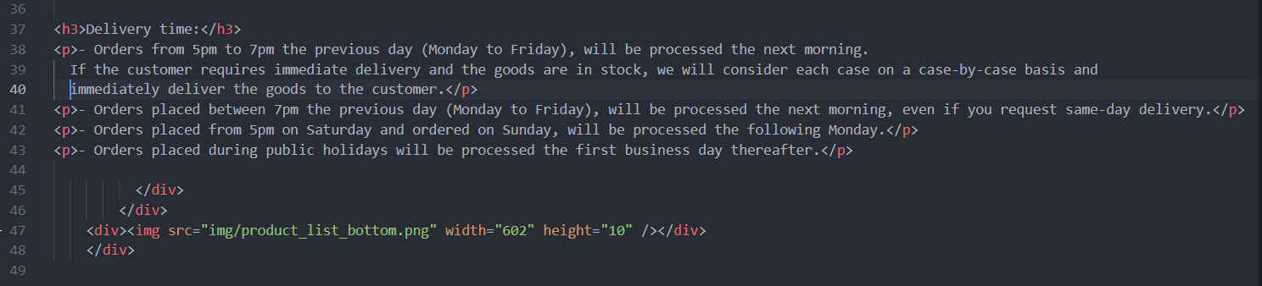

Figure 53: policies (2)

* **productdetail.php**

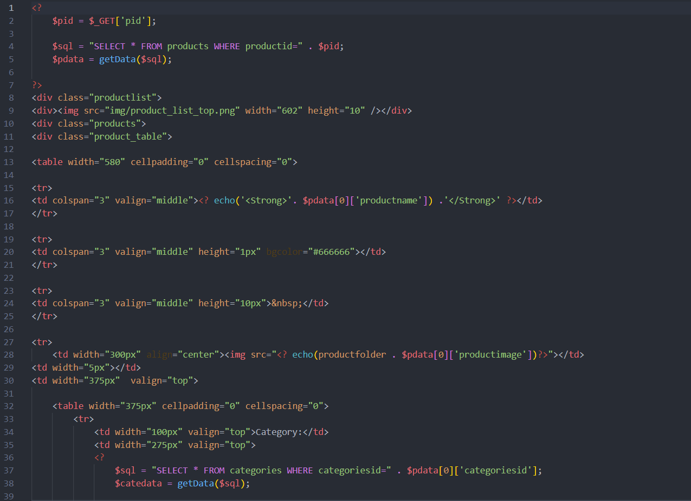

Figure 54: productdetail.php (1)

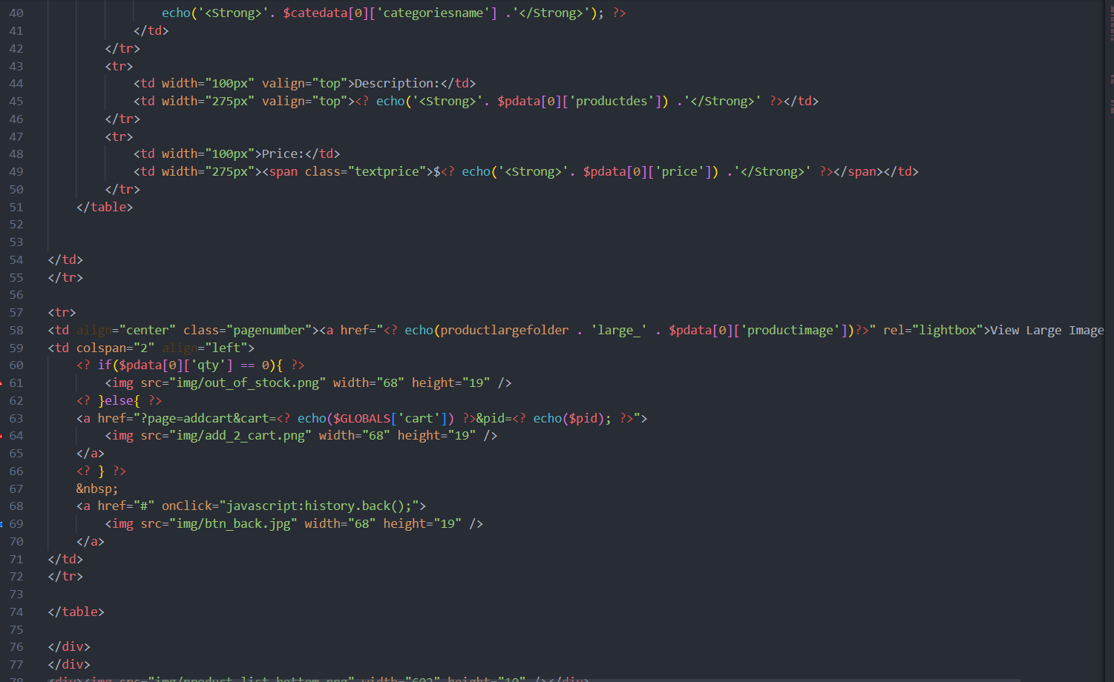

Figure 55: productdetail.php (2)

* **productlist.php**

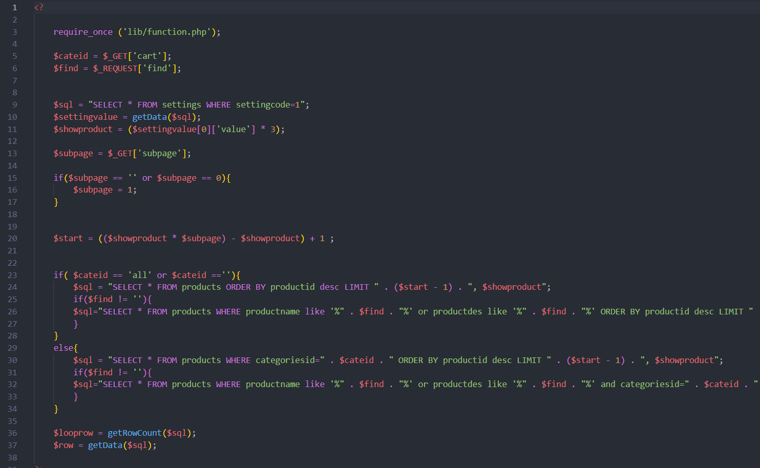

Figure 56: productlist.php (1)

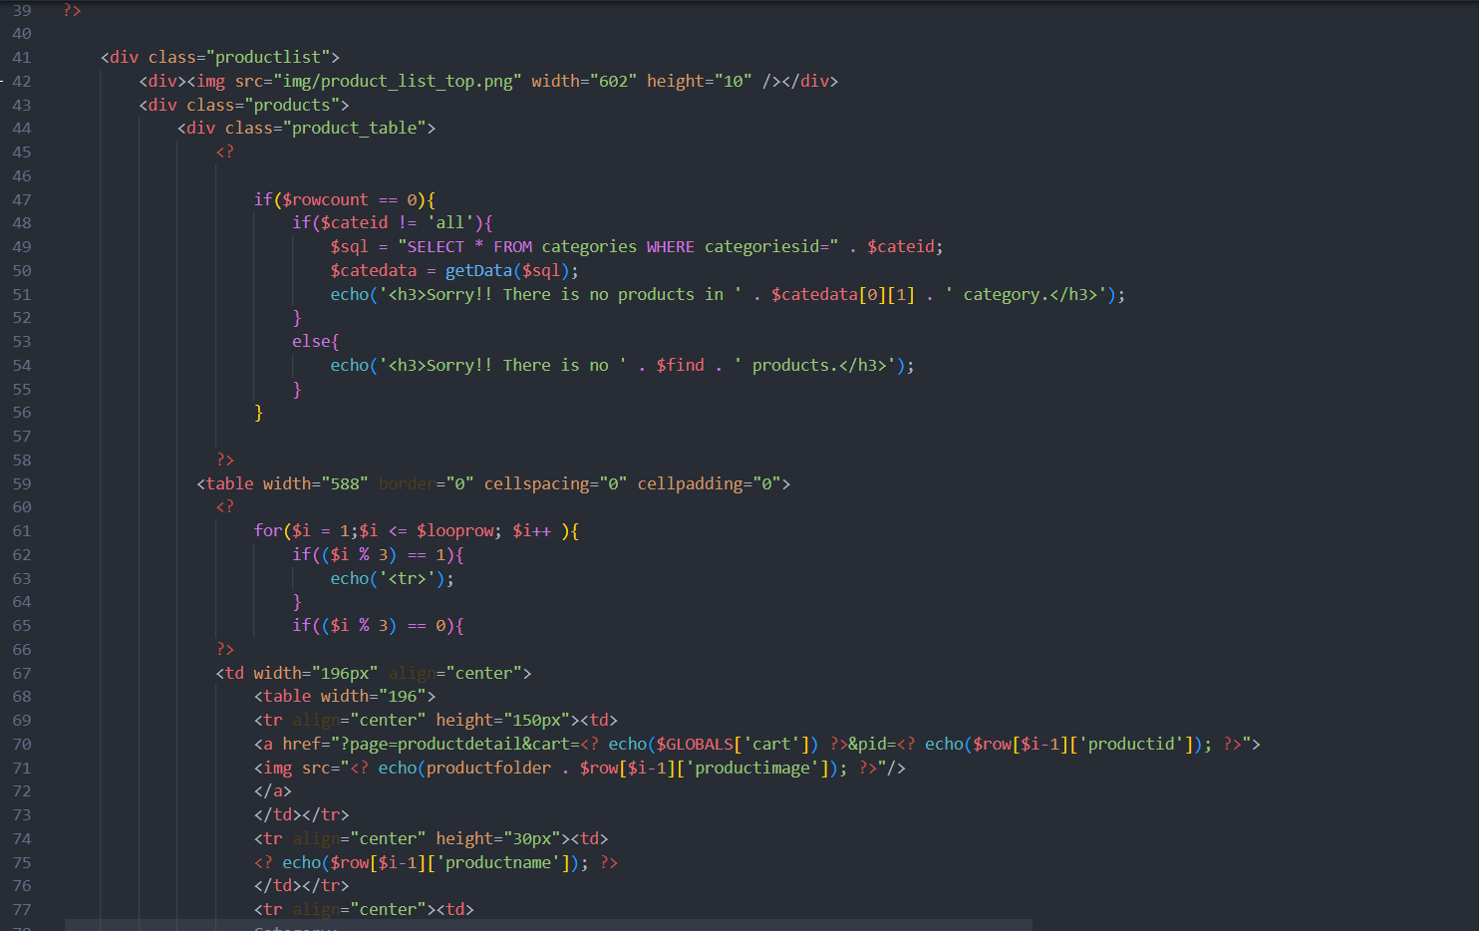

Figure 57: productlist.php (2)

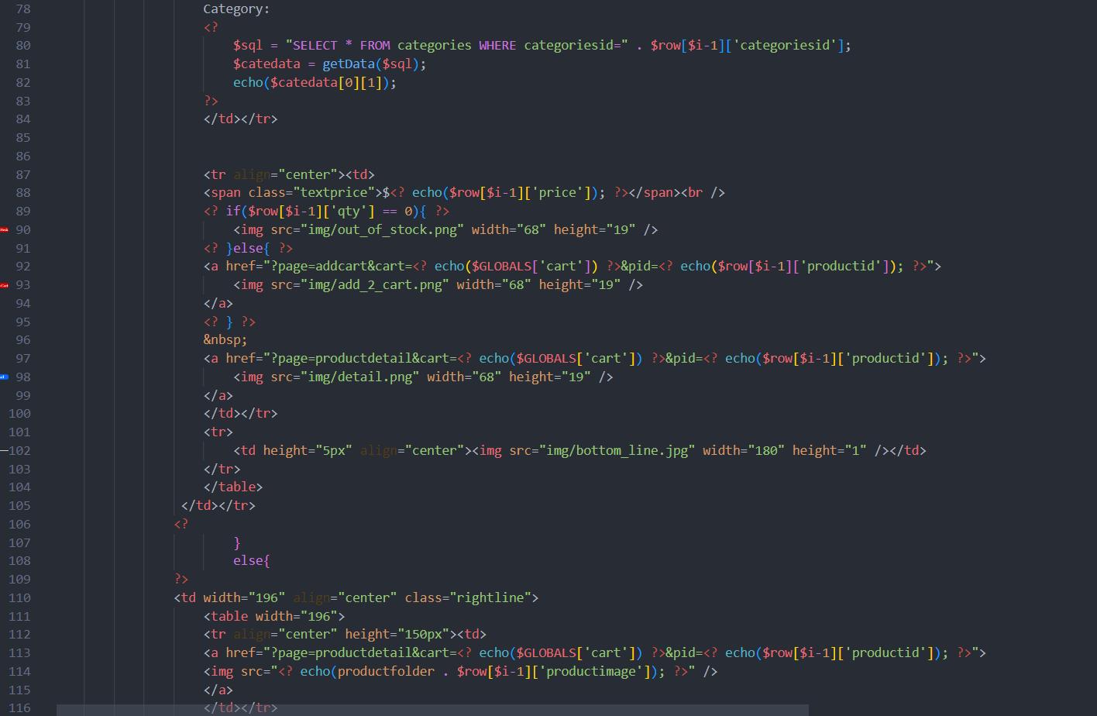

Figure 58: productlist.php (3)

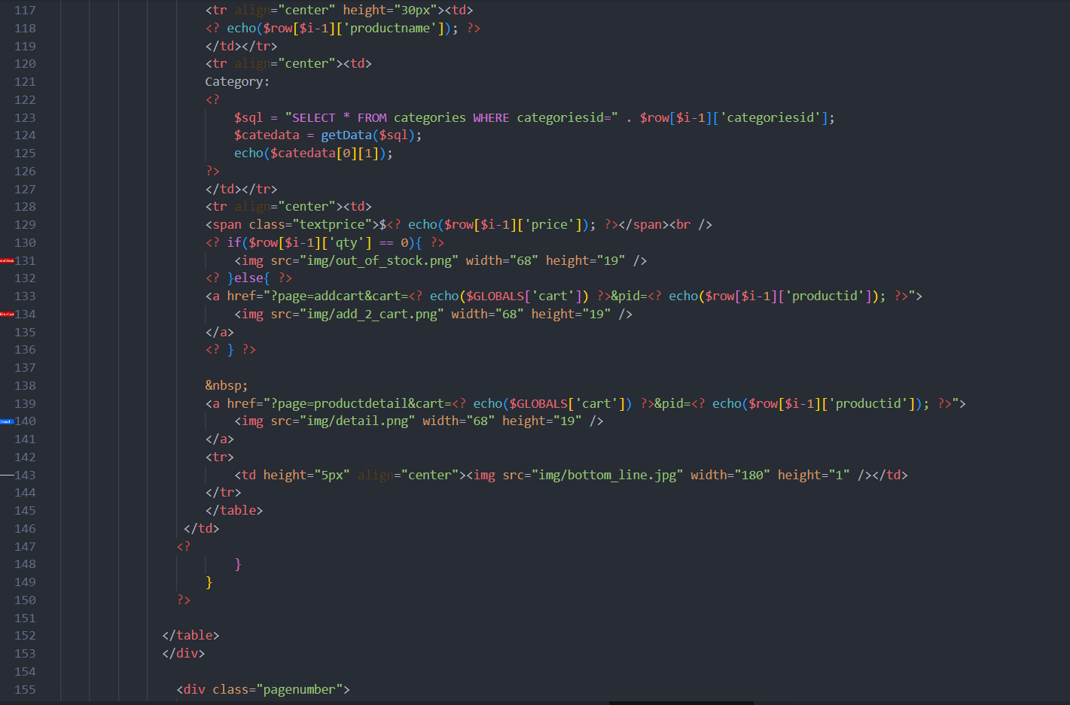

Figure 59: productlist.php (4)

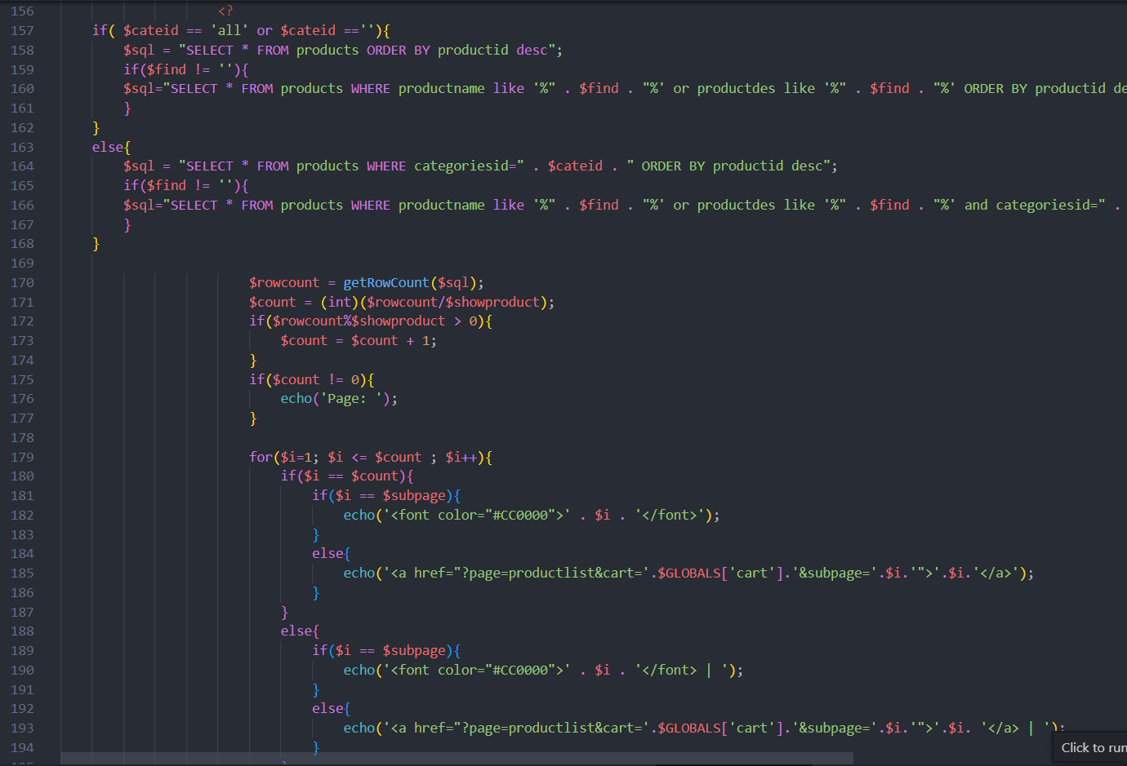

Figure 60: productlist.php (5)

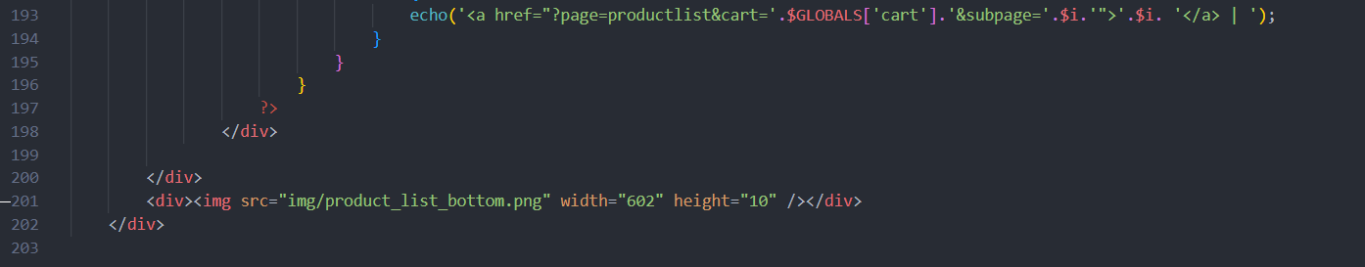

Figure 61: productlish.php (6)

* **registration.php**

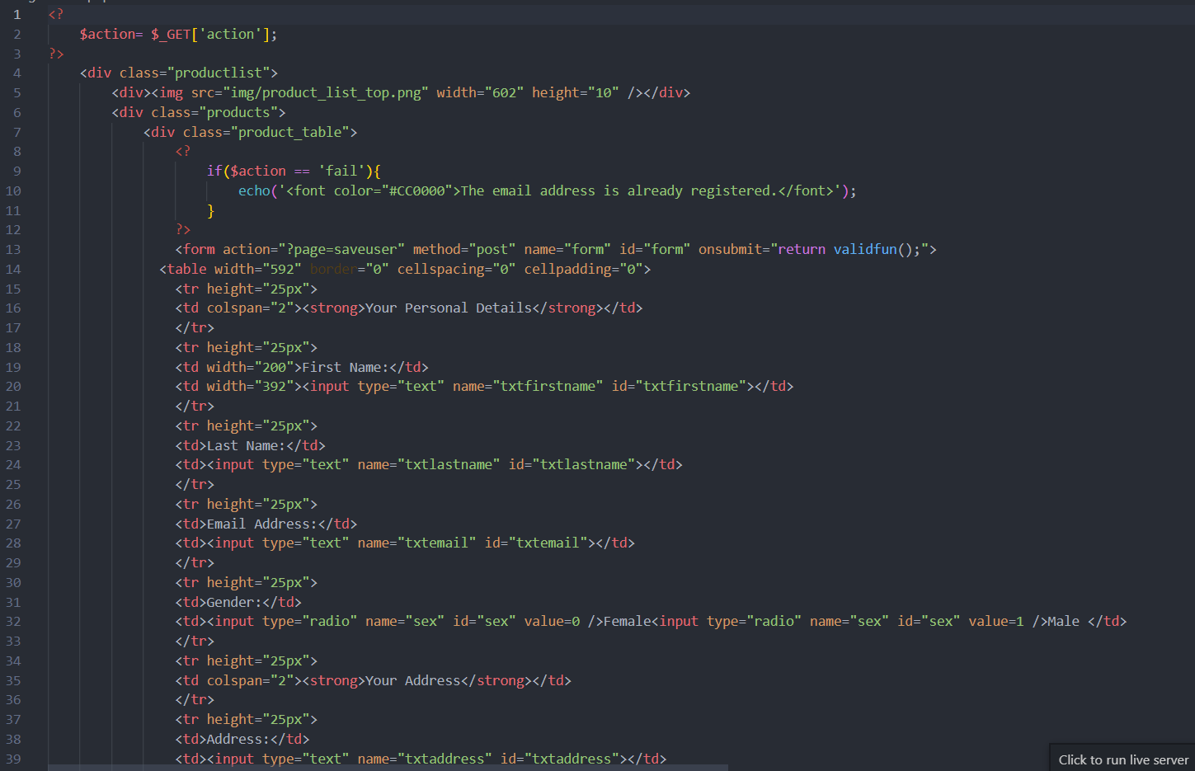

Figure 62: registration.php (1)

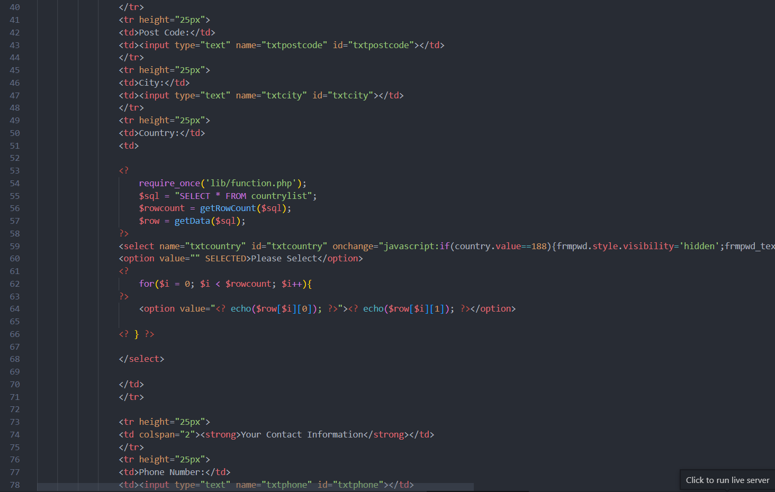

Figure 63: registration.php (2)

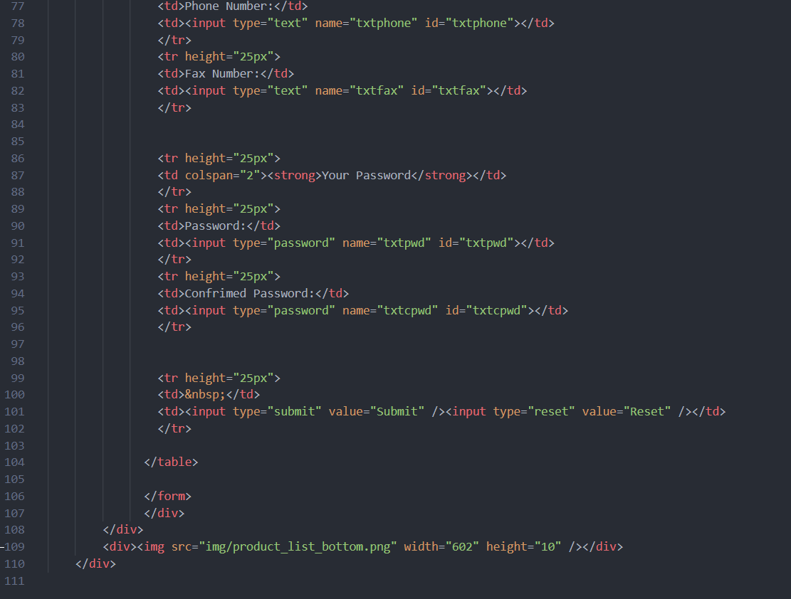

Figure 64: registration.php (3)

* **search.php**

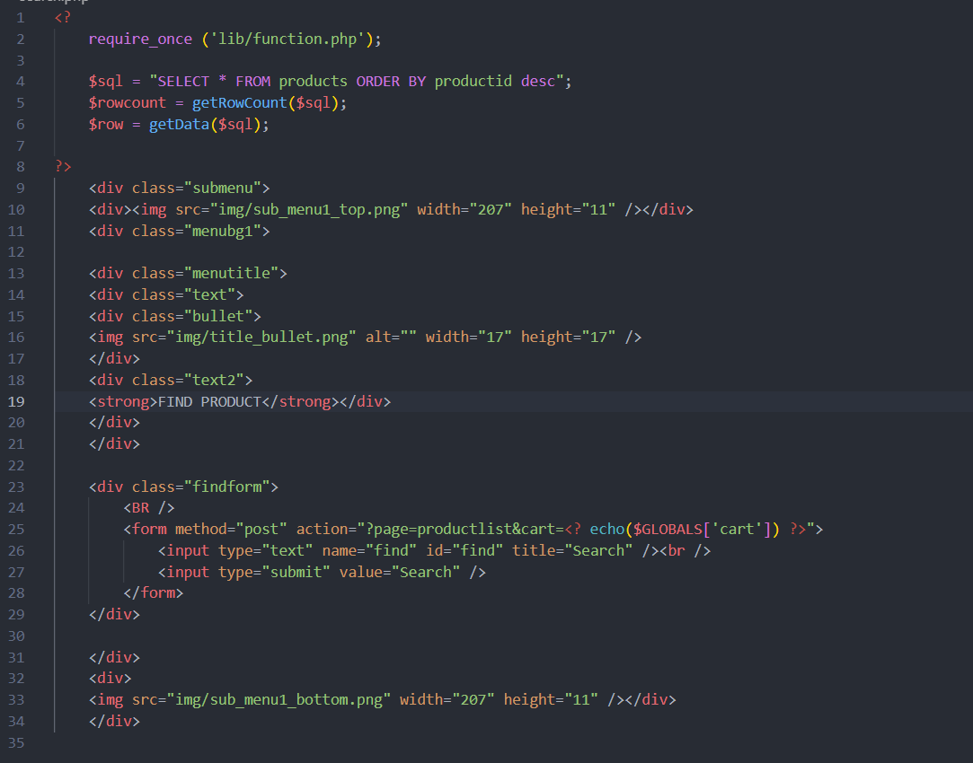

Figure 65: search.php

* **shipment.php**

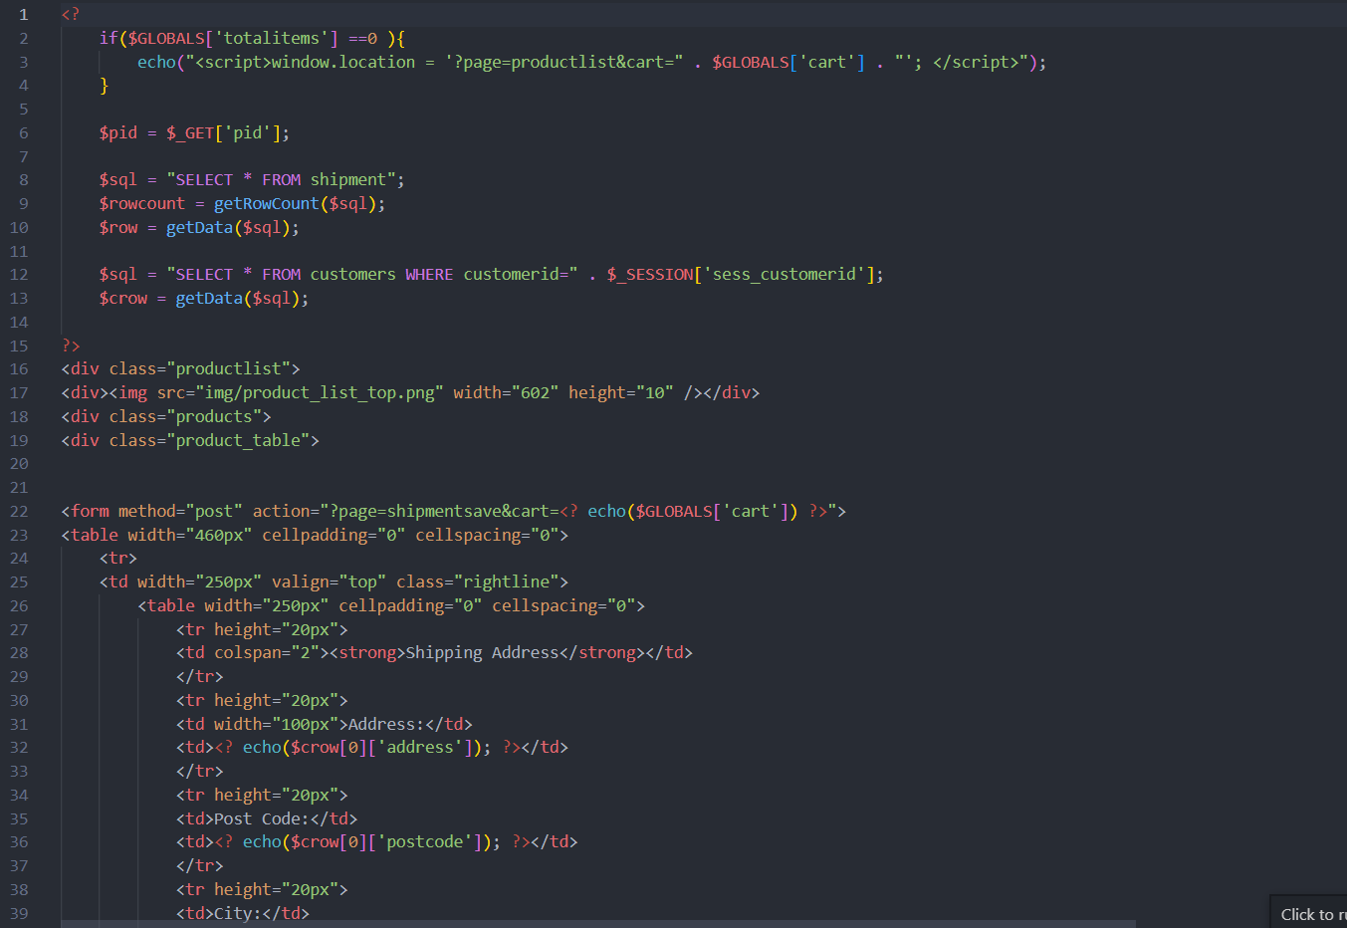

Figure 66: shipment.php (1)

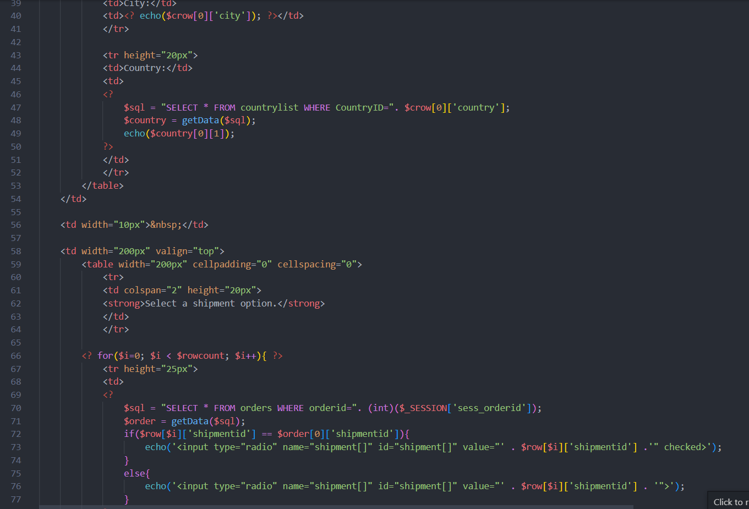

Figure 67: shipmentphp (2)

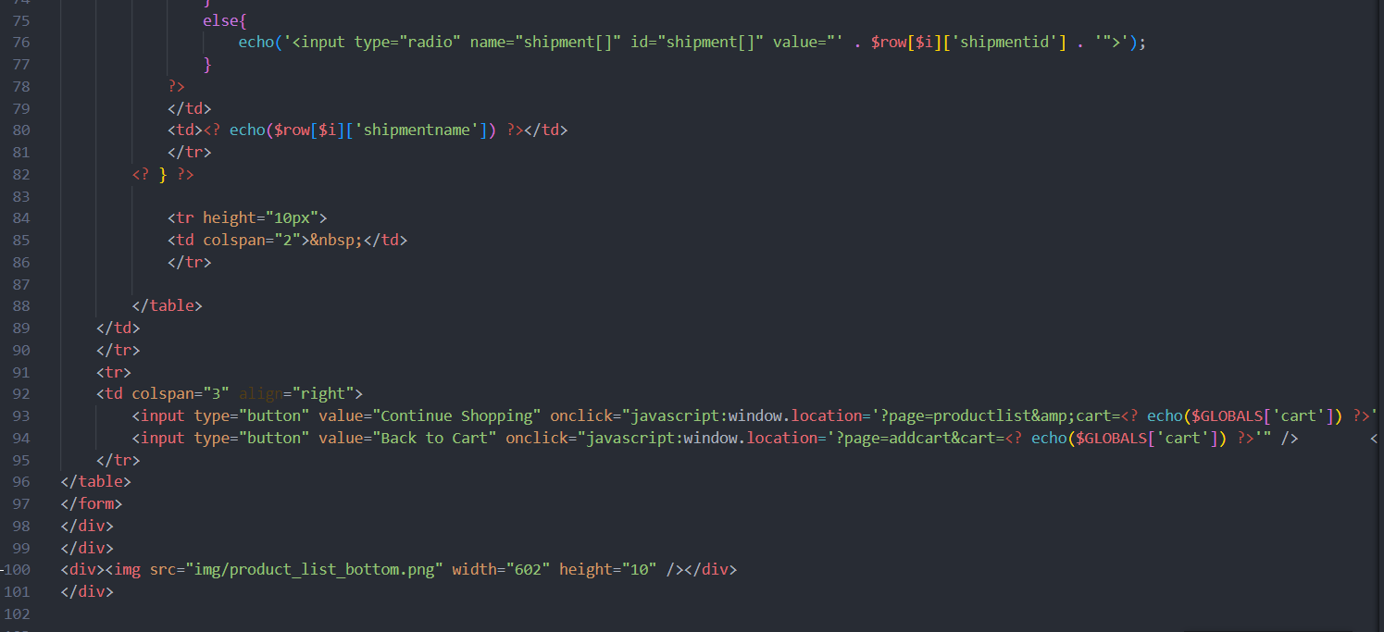

Figure 68: shipment.php (3)

* **shipmentsave.php**

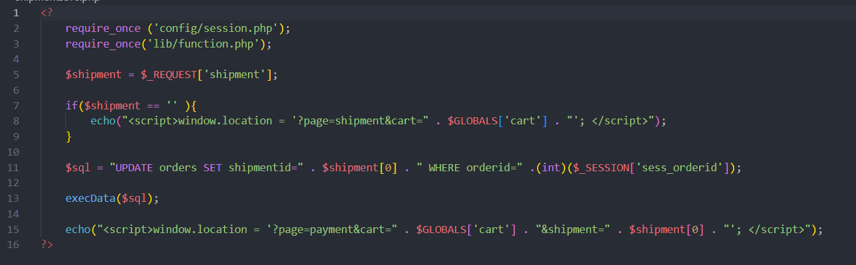

Figure 69: shipmentsave.php

* **special.php**

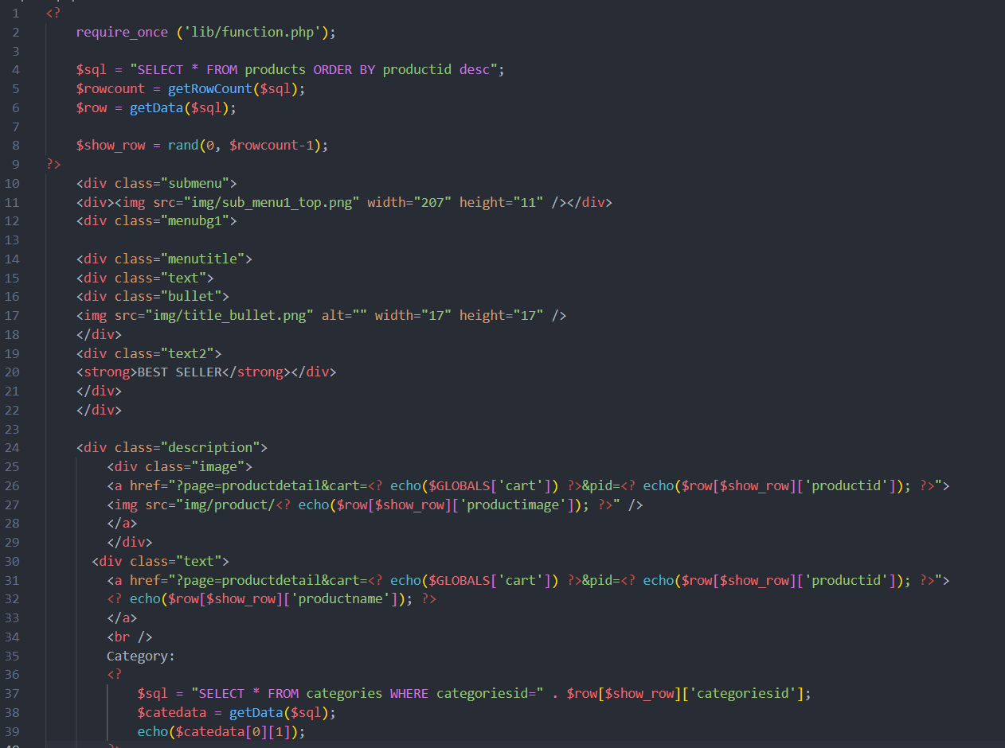

Figure 70: special.php (1)

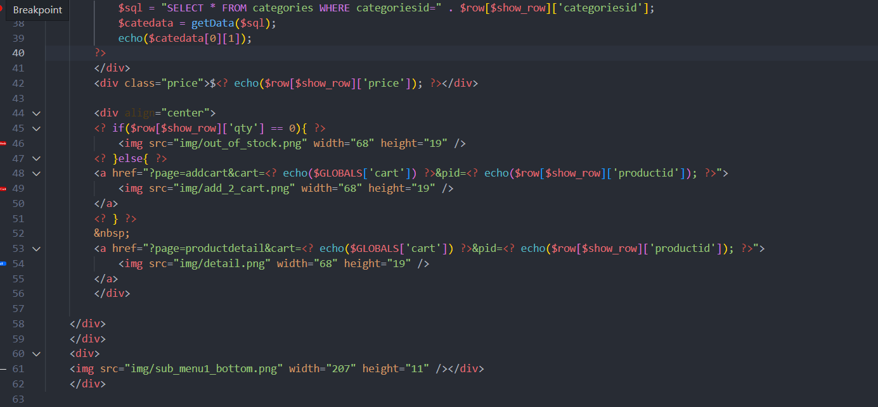

Figure 71: special.php (2)

* **topbanner.php**

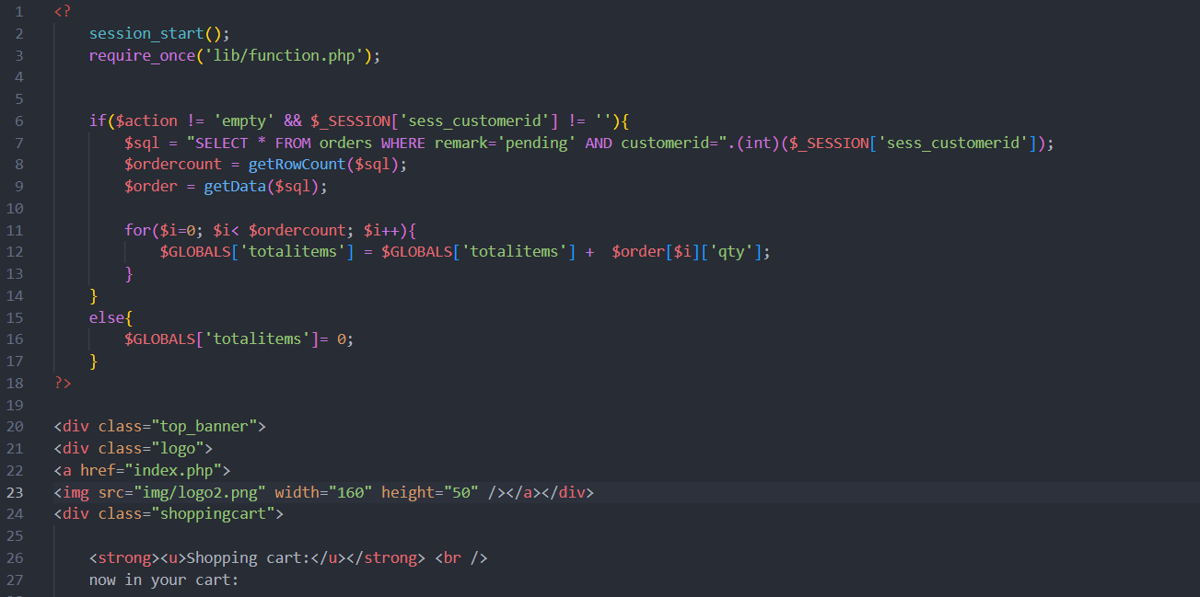

Figure 72: topbanner.php (1)

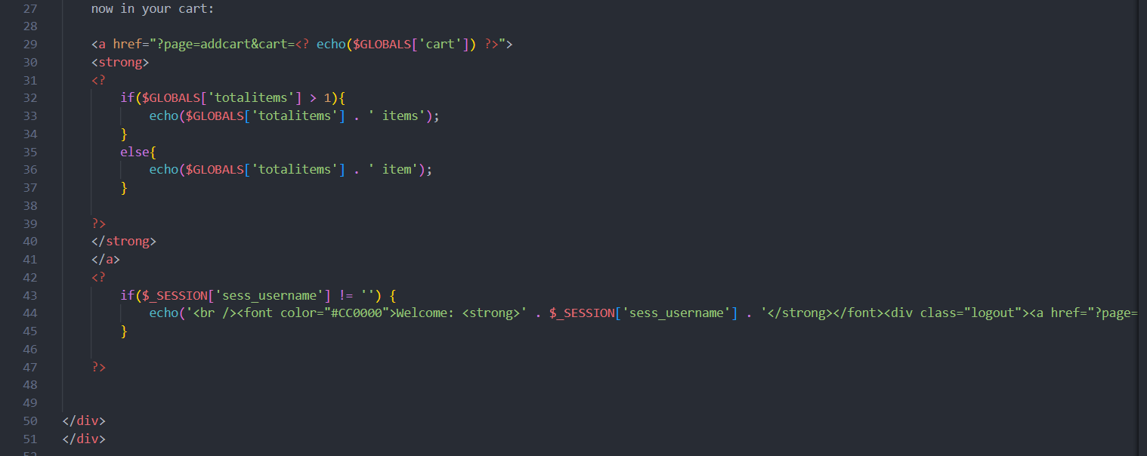

Figure 73: topbanner.php (2)

* **userdetail.php**

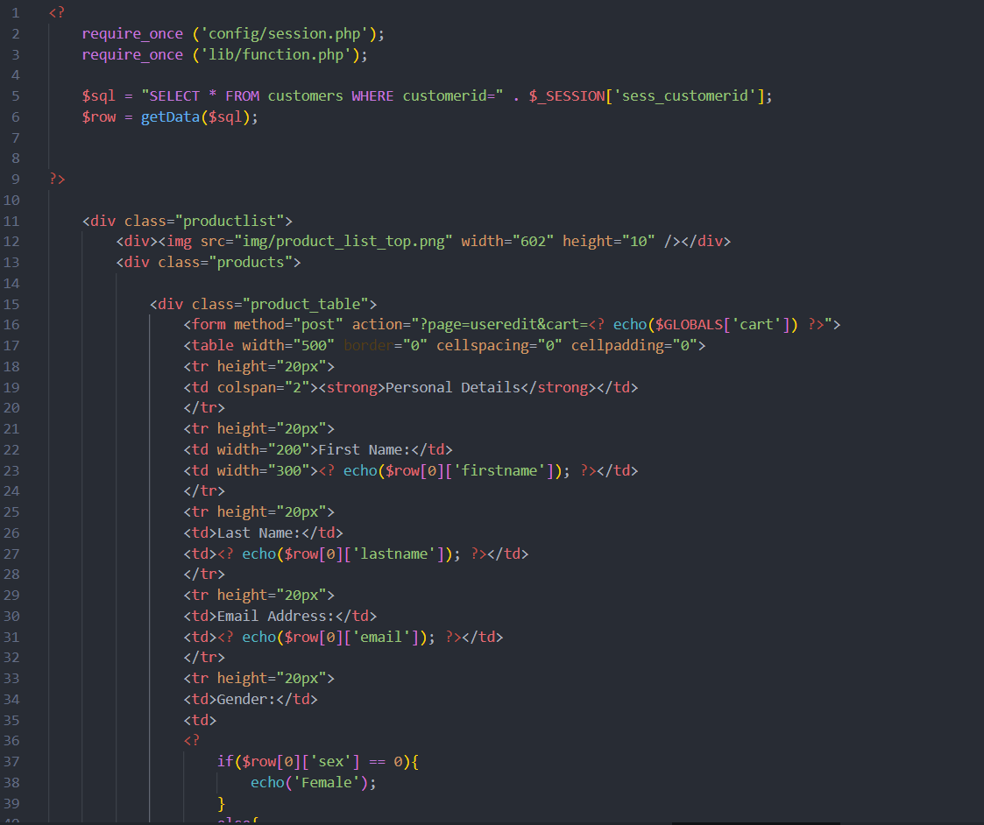

Figure 74: userdetail.php (1)

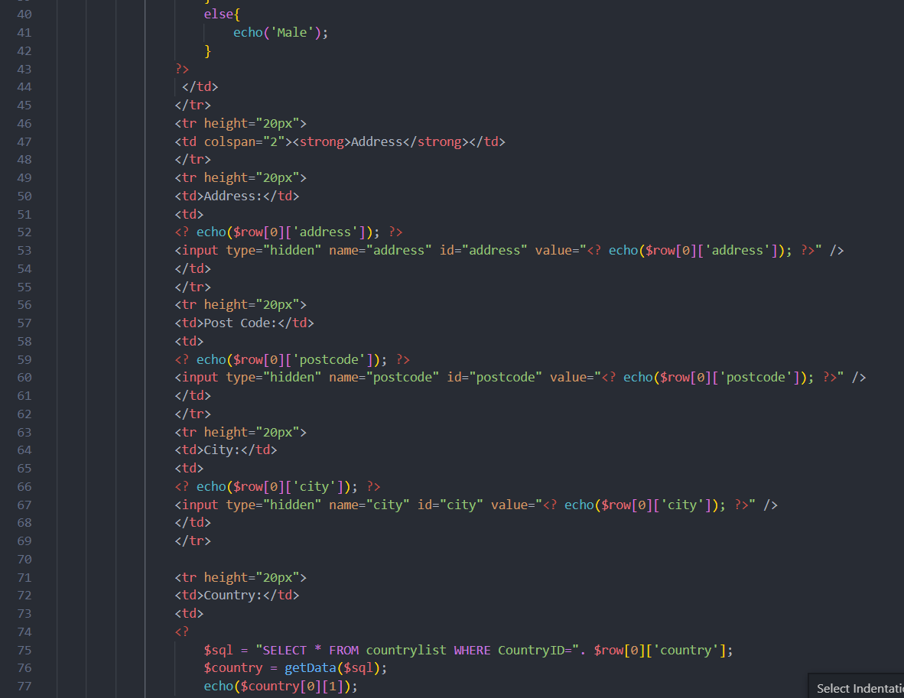

Figure 75: userdetail.php (2)

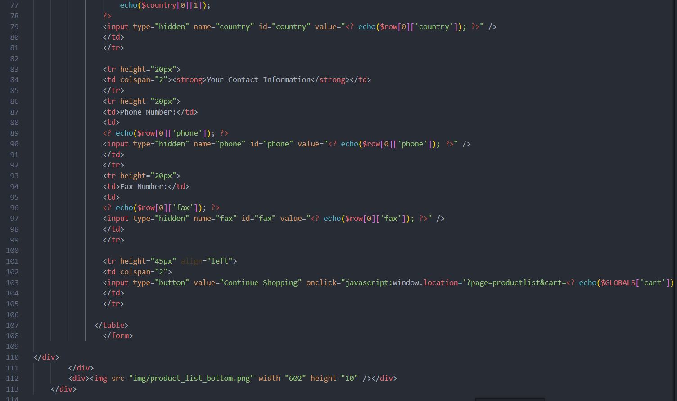

Figure 76: userdetail.php (3)

* **useredit.php**

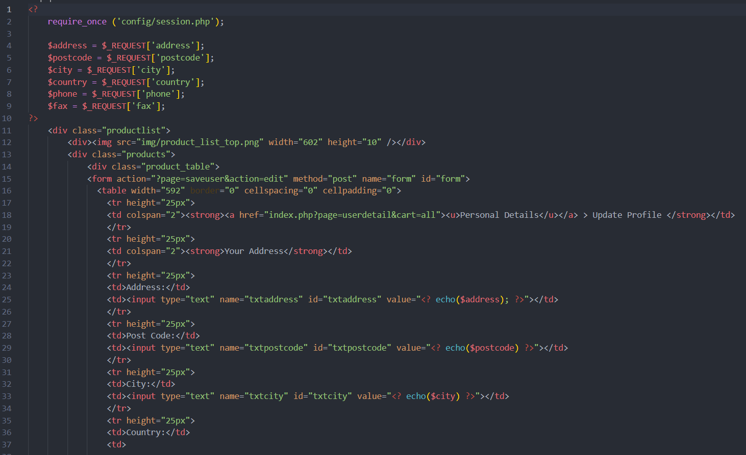

Figure 77: useredit.php (1)

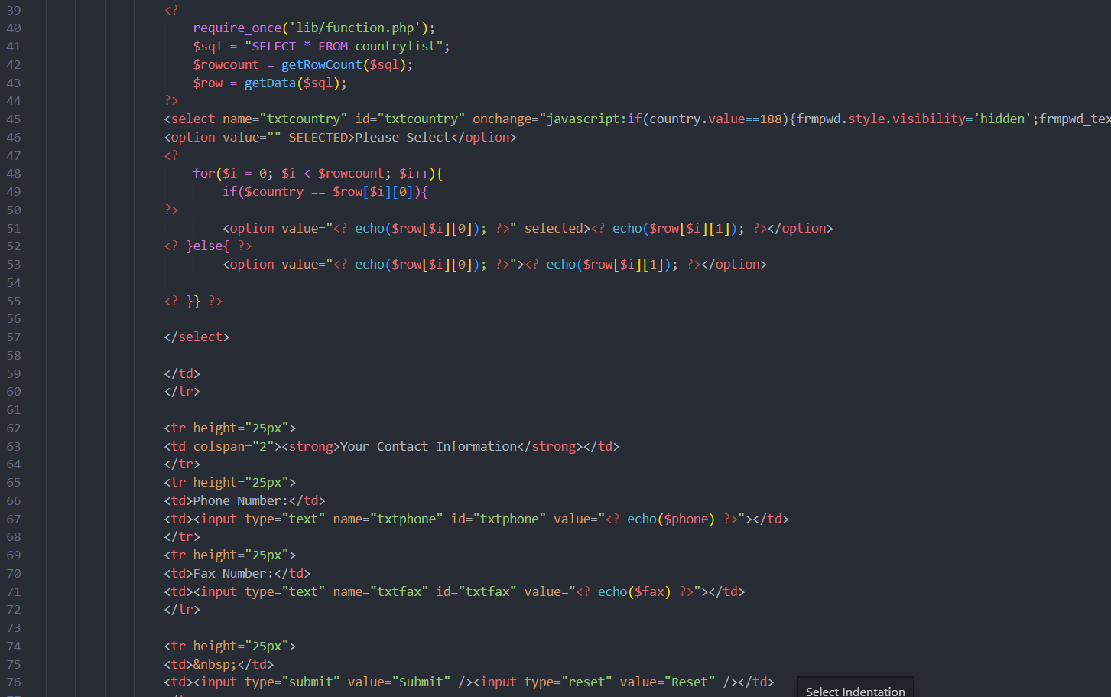

Figure 78: useredit.php (2)

* **validateuser.php**

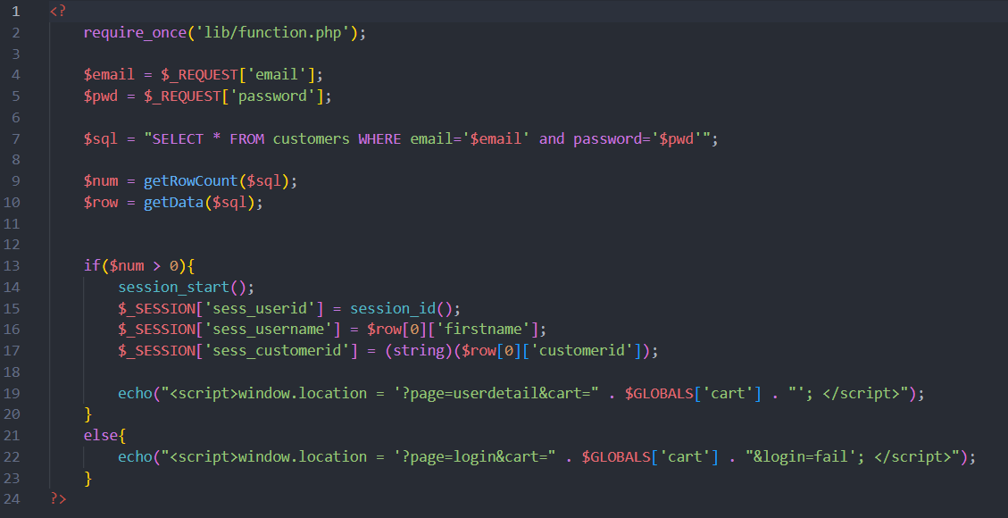

Figure 79: validateuser.php

## Screenshots of Final website with explanation

### Landing page

When customers visit my website, they will see some of my store's latest products as well as some of the best-selling items.

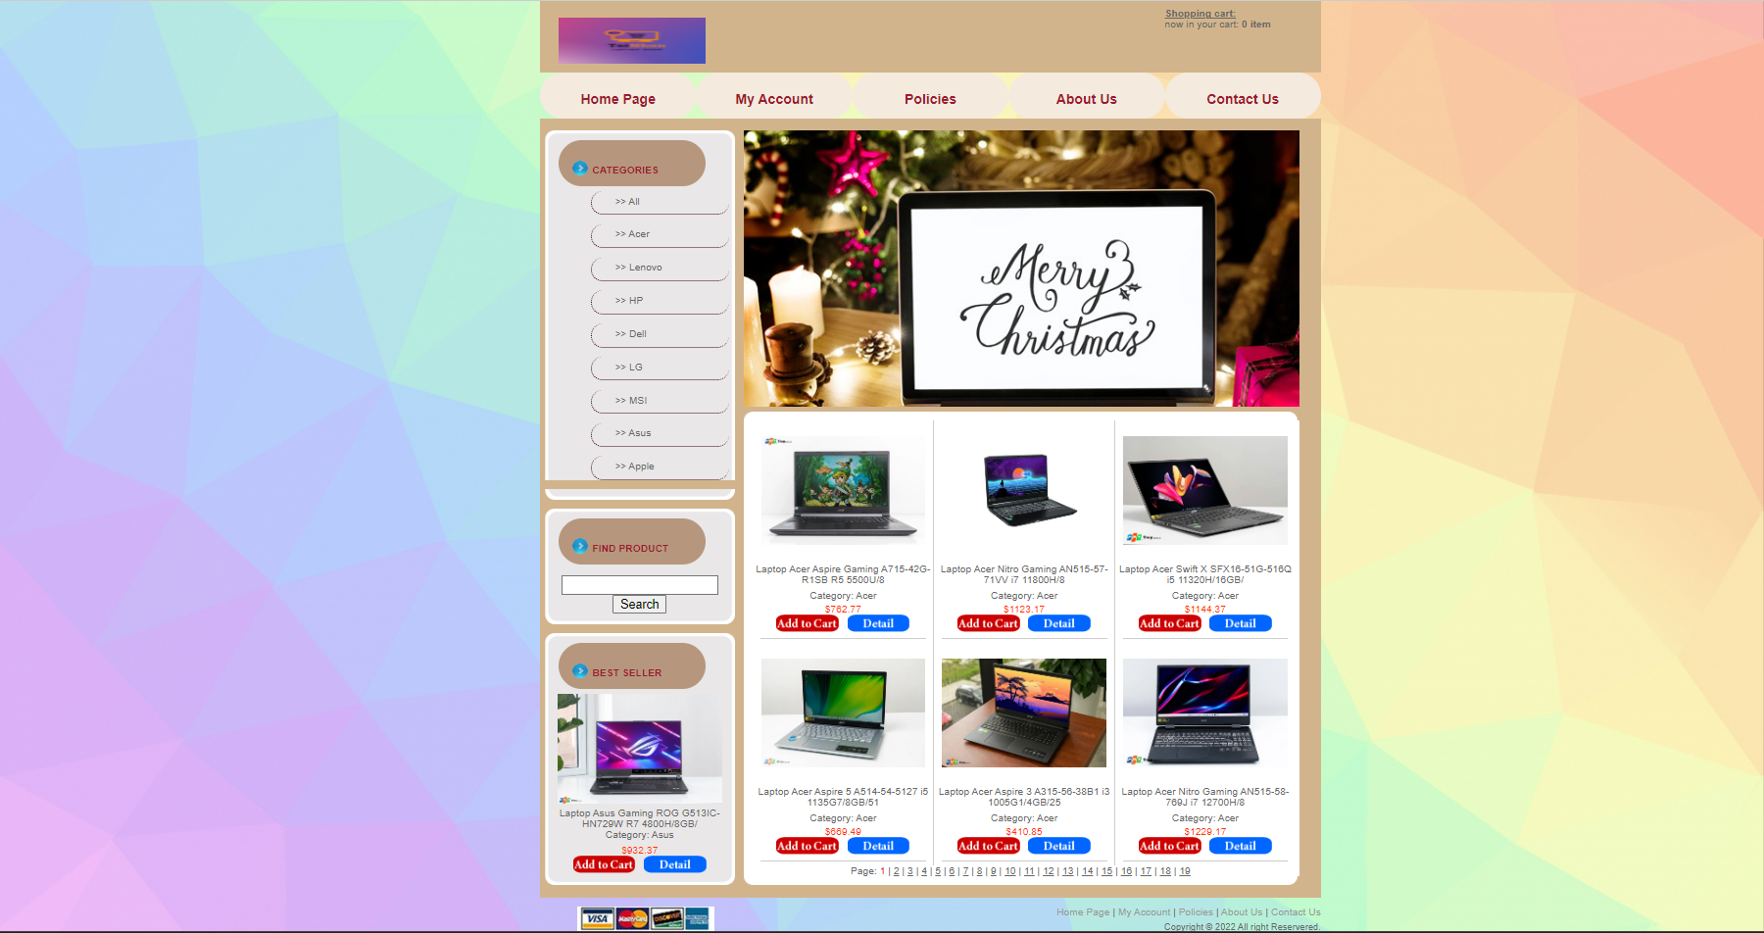

Figure 80: Home page

This site sells only laptops. The store's best-selling items, new products, and promotional banners will all be displayed here. It will also display some other important data.

The Shop Logo, Home, Hot Deals, Feedback, Account and Cart sections make up the title page.

### Register page

This is the UI for the registration page, with a menu bar for simple page navigation and a registration form for the user to set up an account.

The customer fills in the required information, clicks "Sign Up" and is then taken to the login page. The necessary data must be provided to create an account. Consumers can access their accounts by clicking the link below if they already have an account.

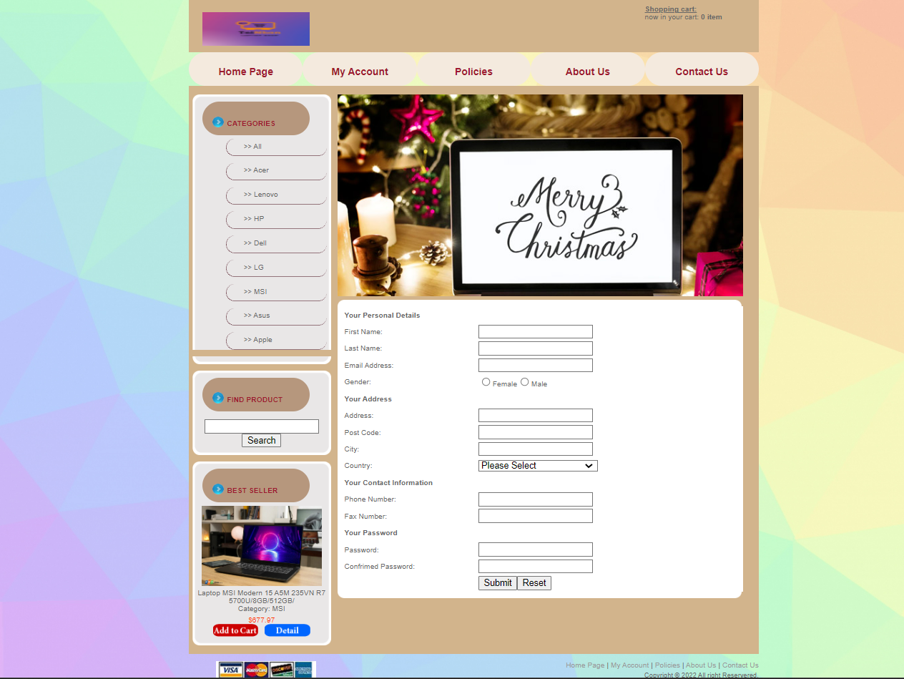

Figure 81: Register page

I established a connection to the database and added restrictions to each field on the form. If a user enters the exact same username or email address, the computer will display "User already exists" and let them reenter until no more matches are found.

To complete the registration process, the confirmation password must also be the same as the one that was previously submitted. The login page will be immediately delivered to the user when the registration process is finished.

### Login page

The following is how the login page looks: The login page only has two fields for users to input in order to make a purchase: email and password. The top navigation bar is still visible.

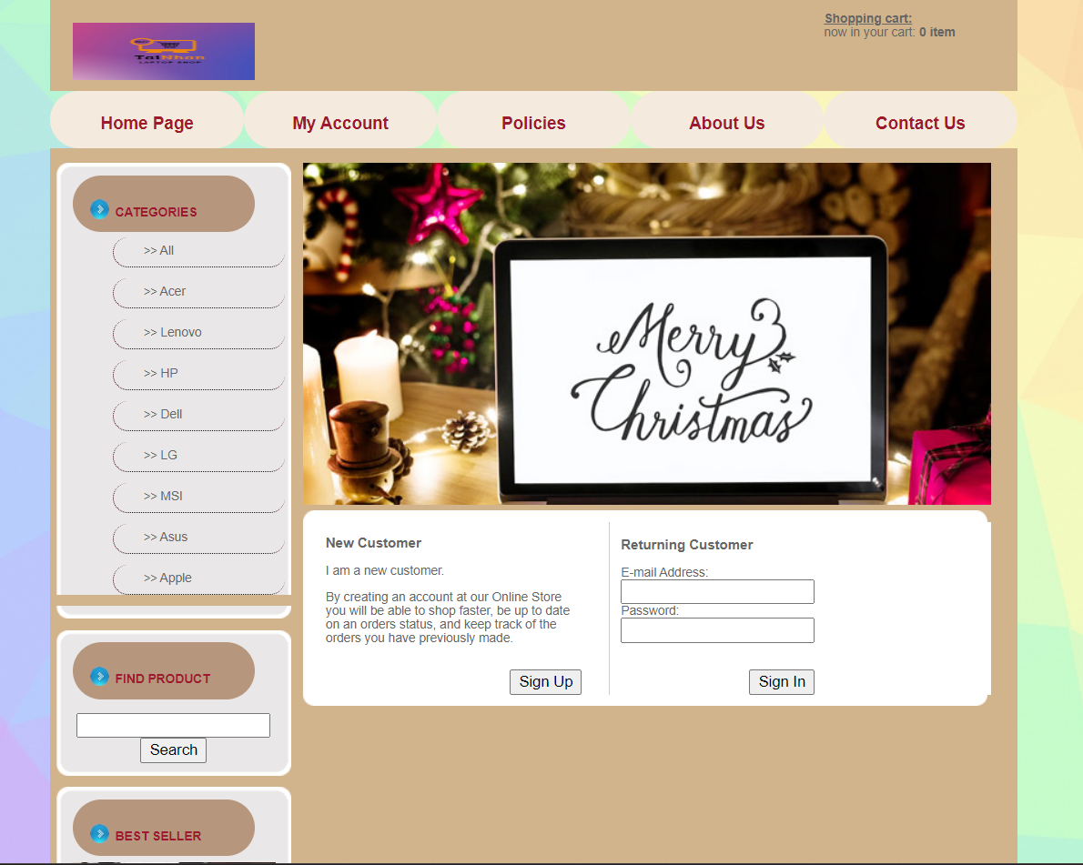

Figure 82: Login Page

Customers fill out the required fields as shown below, after which they click "Login" to continue with their purchase. If the user enters the wrong email address or password while signing in, they will receive a notification and the chance to try again. By clicking the link below to access the signup page, a user who does not currently have an account can create one.

### Profile page and Update profile

After the customer successfully logs in, the customer's information will be displayed right in front of them

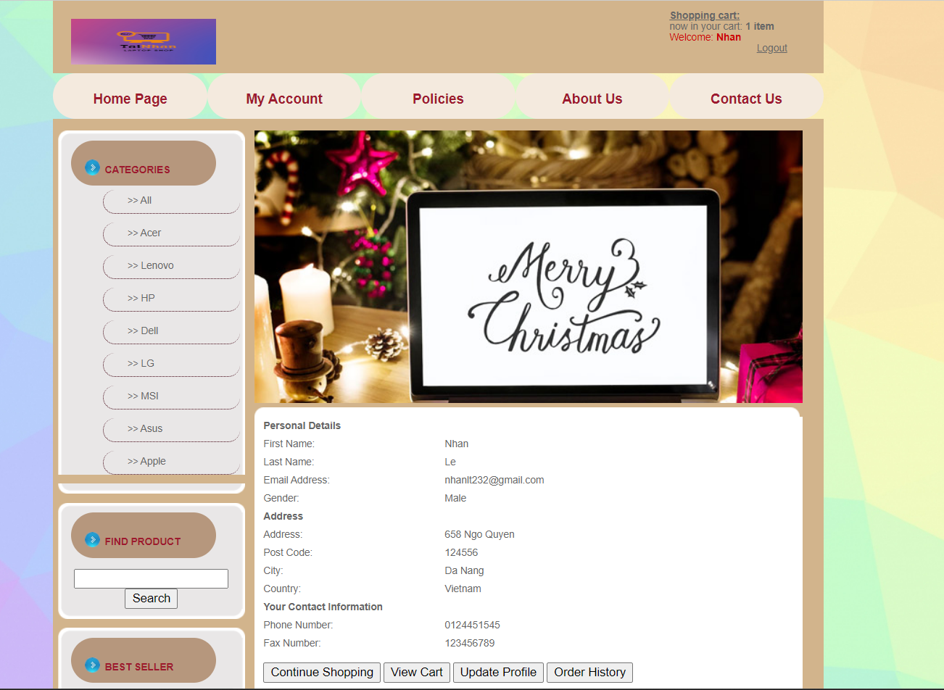

Figure 83: Profile page

When customers need to change information, they can choose "Update profile"

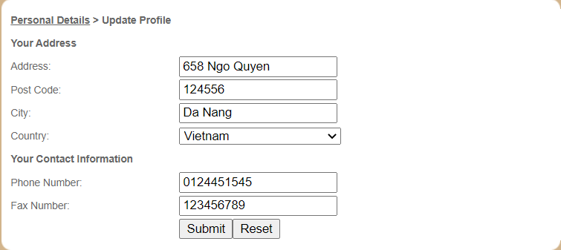

Figure 84: Update profile page

### Cart page

To enter the Cart Page, the customer can choose "View Cart" to view

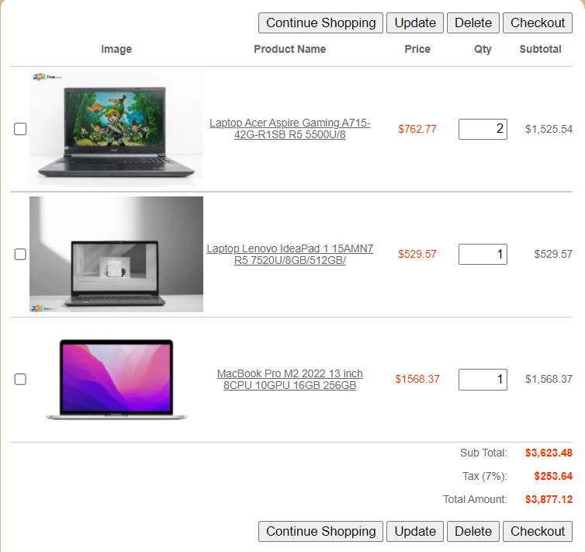

Figure 85: Cart page

## Features of the website

### Create action

When I register a new user, the database If saves all of my registration data, including first name, last name, gender, postcode, city, fax, email, phone number, address, and password, in the Customers table. In this way, a new account is made.



Figure 86: Create action

### Read action

My visit to the My Profile Page to view my information after successfully connecting to the website is utilized as a read action. My information will appear on my profile as follows. This is referred to as "reading a record."

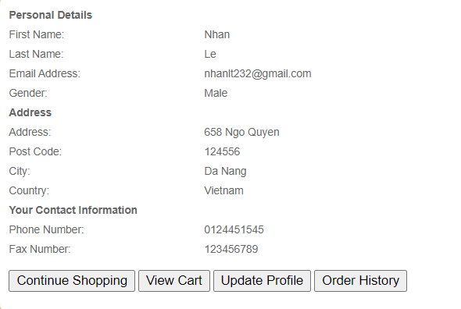

Figure 87: Displayed information

### Update action

When customers need to modify their information, they can update their profile. Things that can be updated are Address, Post Code, City, Country, Phone Number, and Fax number

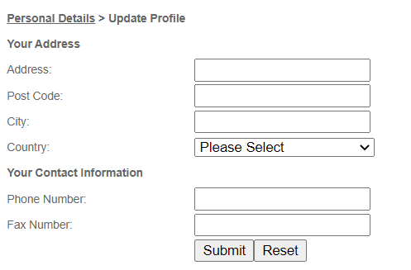

Figure 88: Update action

### Delete action

The Cart Page is the page I am taken to after adding a product to my cart. Here is the newly added item, too. If I decide not to buy this item, I may remove it from my shopping cart by selecting the Delete option.



Figure 89: Delete action

### Search product items by Name

To be able to search for information about a product that customers need to find, customers just need to enter the product name in the bar below "Find Product" then click "Search".

Example: MacBook Air

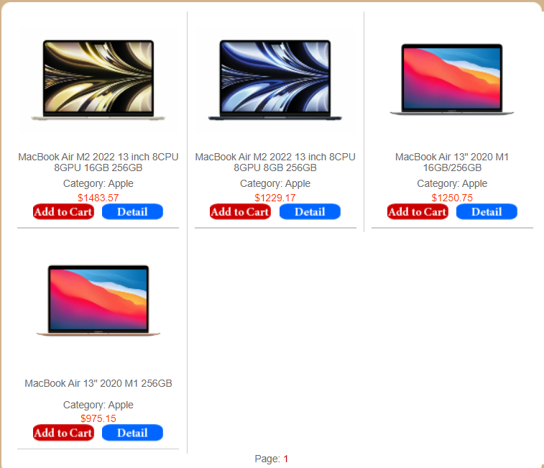

Figure 90: Example of search product

After entering, all products related to MacBook Air will appear for customers to choose.

# CREATE A SUITABLE TEST PLAN IDENTIFYING KEY PERFORMANCE AREA AND USE IT TO REVIEW THE FUNCTIONLITY AND PERFORMANCE OF YOUR WEBSITE. USER EXPERIENCE (UX) AND USER INTERFACE (UI) (P7)

## Test plan

|  |  |  |  |  |  |
| --- | --- | --- | --- | --- | --- |
| **No** | **Test case** | **Input data** | **Expected output** | **Actual result** | **Status** |
| 1 | Log in with your previously registered account | ‘hoalang@gmail.com’,’123456’ | Logged in successfully | Figure 91 | Pass |
| 2 | View product details | See details of Laptop Lenovo Gaming Legion 5 15IAH7 i5 12500H/16G | Show details about that product | Figure 92 | Pass |
| 3 | buy some products then check cart | MacBook Air M2 2022 13-inch 8CPU 8GPU 16GB 256GB  Laptop Dell Vostro V3510 i5 1135G7/8GB/512GB/15.6F  Laptop Acer Nitro Gaming AN515-58-769J i7 12700H/8 | All selected products are in the shopping cart | Figure 93 | Pass |
| 4 | Remove products from cart | Laptop Dell Vostro V3510 i5 1135G7/8GB/512GB/15.6F | Deleted product is no longer in cart | Figure 94 | Pass |
| 5 | Check out the products in the cart | Shipment Type: TNT  Payment Type: Credit Card | Print out invoices for customers | Figure 95 | Pass |

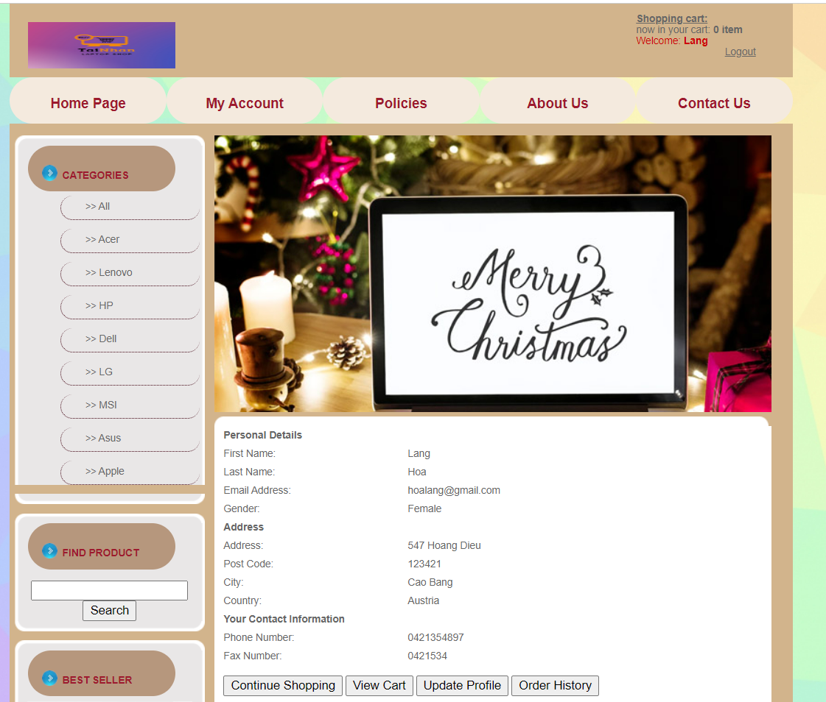

Figure 91

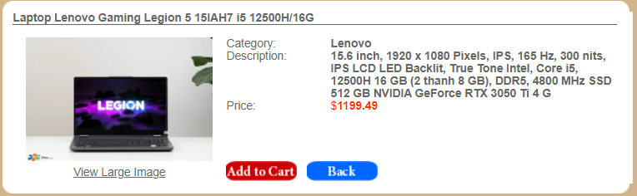

Figure 92

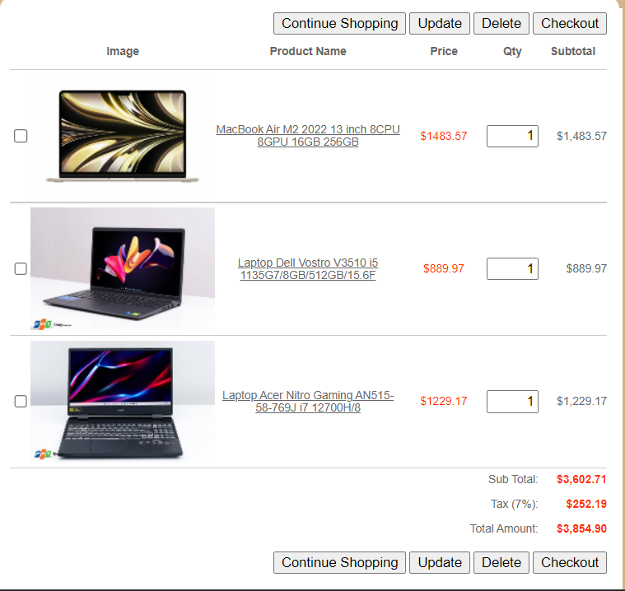

Figure 93

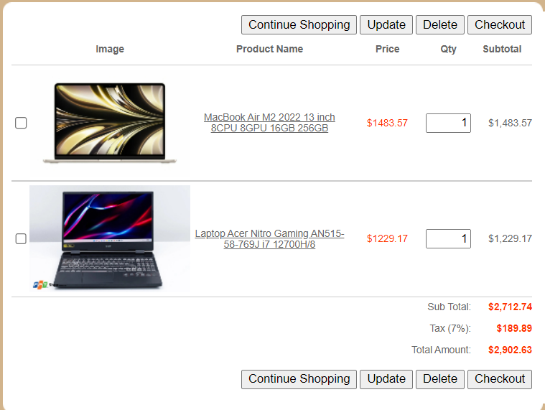

Figure 94

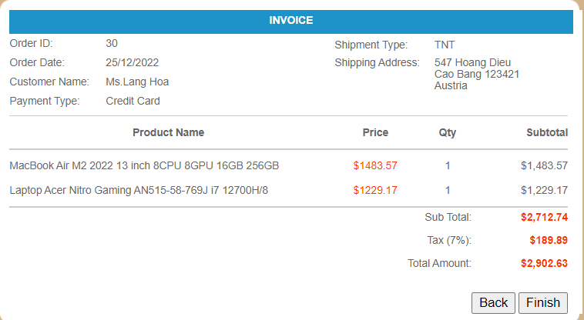

Figure 95

# References

Henry, S. L., 2022. *W3C Accessibility Standards Overview.* [Online]   
Available at: https://www.w3.org/WAI/standards-guidelines/  
[Accessed 25 December 2022].

***Driver:*** https://drive.google.com/file/d/1aLJoLCEQuCchsVpbGYdx2u_ZJkqLFWxp/view?usp=share_link